PANEL HEATER

INSTRUCTION MANUAL

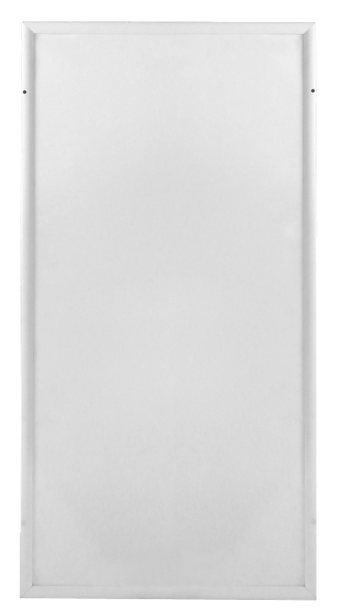



SYMBOLS
Warning
This signal word indicates a hazard with an average
risk level which, if not avoided, can result in serious
injury or death.
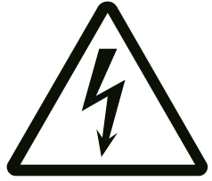Warning of electrical voltage
This symbol indicates dangers to the life and health of
persons due to electrical voltage.

Symbols | Meaning
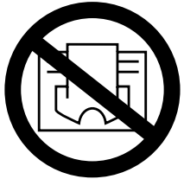 | This symbol located on the device indicates that it is  prohibited to place objects (such as towels, clothes etc.)  above or directly in front of the device.  In order to avoid overheating and fire hazards, the device  must not be covered.
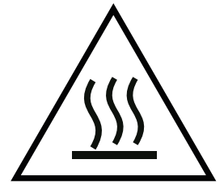 | This symbol located on the device indicates dangers to the  life and health of persons due to hot surface.
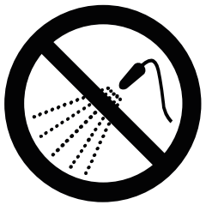 | This symbol located on the device indicates that it is  prohibited to spray the device.
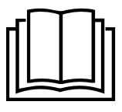 | This symbol located on the device and information marked indicates that operating manual must be observed.

CONTENT

1┃WARNING & PRECAUTION 2┃FEATURES 3┃TECHNICAL INFORMATION

4┃SCOPE OF SUPPLY 5┃DEVICE STRUCTURE 6┃INSTALLATION 7┃TROUBLESHOOTING 8┃MAINTENANCE & SERVICING

9┃STORAGE

10┃DISPOSAL

1┃WARNING & PRECAUTION
Read this manual carefully before starting or using the
device. Always store the manual in the immediate vicinity
of the device or its site of use!

Read all safety warnings and all instructions.
Failure to follow the warnings and instructions may result in electric shock, fire and / or serious injury. Save all warnings and instructions for future reference.
Warning
HH series are ceiling mounted only！
HL series can be wall and ceiling mounted.
Make sure the series you bought and install it in accordance to the tips in installation part!
Warning
This appliance can be used by children aged from
8 years and above and persons with reduced physical,
sensory or mental capabilities or lack of experience
and knowledge if they have been given supervision or
instruction concerning use of the appliance in a safe
way and understand the hazards involved.
Children shall not play with the appliance. Cleaning and
user maintenance shall not be made by children
without supervision.
Warning
Children of less than 3 years should be kept away
unless continuously supervised.
Children aged from 3 years and less than 8 years shall
only switch on/off the appliance provided that it has
been placed or installed in its intended normal
operating position and they have been given
supervision or instruction concerning use of the
appliance in a safe way and understand the hazards
involved.
Children aged from 3 years and less than 8 years shall
not plug in, regulate and clean the appliance or
perform user maintenance.
Warning
Do not use the device in small rooms if persons are
present who cannot leave the room independently and
who are not under constant supervision.
Warning
Some parts of this product can become very hot and cause
burns. Particular attention has to be given where children
and vulnerable people are present. Its dangerous of
installation close to curtains and other combustible
materials. To avoid the possibility of burns, the following
people should be much more careful when using the
heaters: infants and kids, people with sensitive skin, the
old, the sick, people who is drunk, people who takes sleeping
pills.
• Remove the protective film(on the front) before using.
• Be sure the input voltage is between 220-240V, 50Hz, and power supply has been strictly in accordance with IEC, left is null wire and right is live wire, and also well grounded.
• The devices will draw more current than small appliances, so a
separate 10A+ socket is required.
• Do not use the device in potentially explosive rooms.
• Do not use the device in aggressive atmosphere.
• Set the device up in an upright and stable position.
• Let the device dry out after a wet clean. Do not operate it when wet.
• Do not use the device with wet or damp hands.
• Do not expose the device to directly squirting water.
• Never insert any objects or limbs into the device.
• Do not cover or transport the device during operation.
• Do not sit on the device.
• This appliance is not a toy! Keep away from children and animals. Do
not leave the device unattended during operation.
• Check accessories and connection parts for possible damage prior to
every use of the device. Do not use any defective devices or device
parts.
• Ensure that all electric cables outside of the device are protected from
damage (e.g. caused by animals). Never use the device if electric
cables or the power connection are damaged!
• The electrical connection must correspond to the specifications in
chapter Technical data.
• Insert the mains plug into a properly secured mains socket.
• Do not use the device when the socket or wire overloaded.
• Observe the device's power input, cable length and intended use when
selecting extensions to the power cable. Completely unroll extension
cables. Avoid electrical overload.
• Before carrying out maintenance, care or repair work on the device,
remove the mains plug from the mains socket. Hold onto the mains
plug while doing so.
• Switch the device off and disconnect the power cable from the mains
socket when the device is not in use.
• Do not under any circumstances use the device if you detect damages
on the mains plug or power cable. If the supply cord is damaged, it
must be replaced by the manufacturer, its service agent or similarly
Qualified persons in order to avoid a hazard. Defective power cables
pose a serious health risk.
• During the installation of the device observe the minimum distances
from walls and other objects as well as the storage and operating
conditions specified in the Technical data chapter.
• Never drill into the heating device.
• Do not use the device in immediate proximity to curtains.
• Do not place the device on combustible ground.
• Do not transport the device during operation.
• Do not touch the surface during the device working to avoid burns.
• Allow the device to cool down before transport and / or maintenance
work.
• Do not use this device near bathtubs, shower trays, swimming pools or
other water containers. Risk of electric shock!
• The device must be placed where the switches and controllers cannot
be touched by a person in a bathtub or shower.
• Do not use this device in a child-care centre and bathroom.(Only for
Sweden)
• Wall mounted panels must be higher than 0.6meters.
• Ceiling mounted panels must be higher than 1.8meters.

2┃FEATURES
• The device is designed to provide an efficient, comfortable and
healthy heating system for any domestic users.
• These devices can reduce air circulation and help to maintain a
clean, silent, dust free environment.
• Unless stated, all the devices should be wall mounted.
Only specific models are designed for ceiling mounting, please check with supplier before mounting to the ceiling.
• A wide range of devices available in a huge choice of colors, sizes and styles.

3┃TECHNICAL INFORMATION

HH series ( ceiling mounted only)
Heating element | Nicr heating wire
Heating way | Far infrared heating
Input Voltage | 220-240V/50Hz
Surface temperature | Mainly 130℃
Frame | Aluminum
IP grade | IP54 (exclude plug)
Over heating protection | Yes
Power cord length | 1.9m

Model NO. | Size(cm) | Power  (W)
0606 | 63*63*2.1 | 450
0806 | 83*63*2.1 | 600
1006 | 103*63*2.1 | 700
1206 | 123*63*2.1 | 900
1506 | 153*63*2.1 | 1200
1806 | 183*63*2.1 | 1400

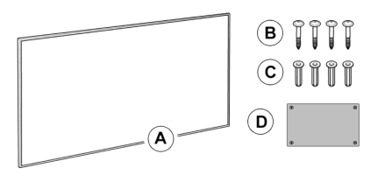
4┃SCOPE OF SUPPLY

A

Only for ceiling products

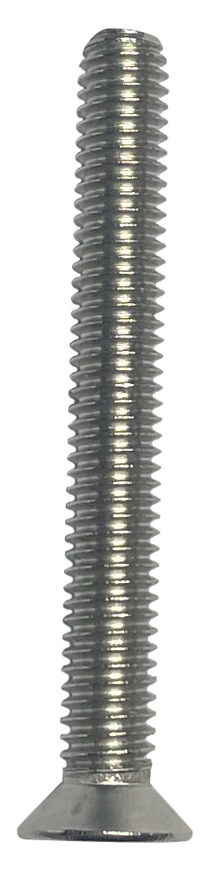
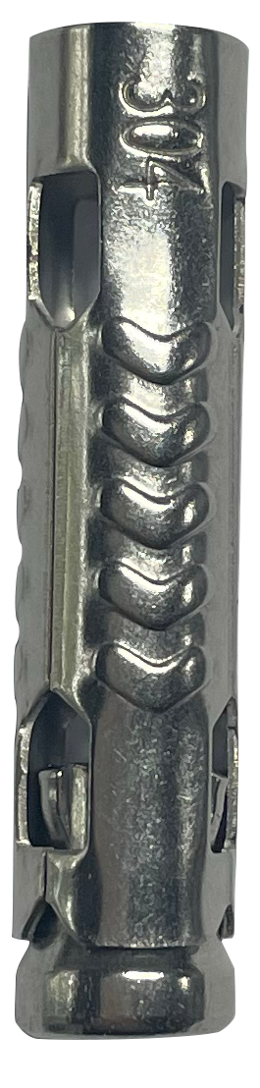

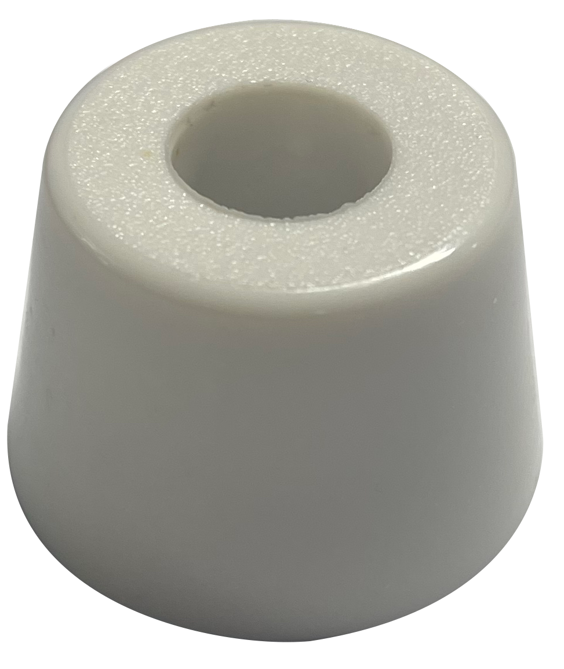
B
G
H

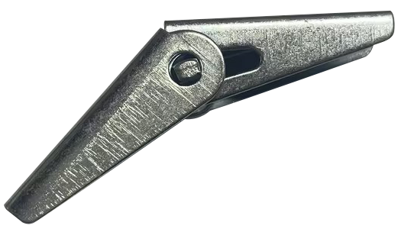
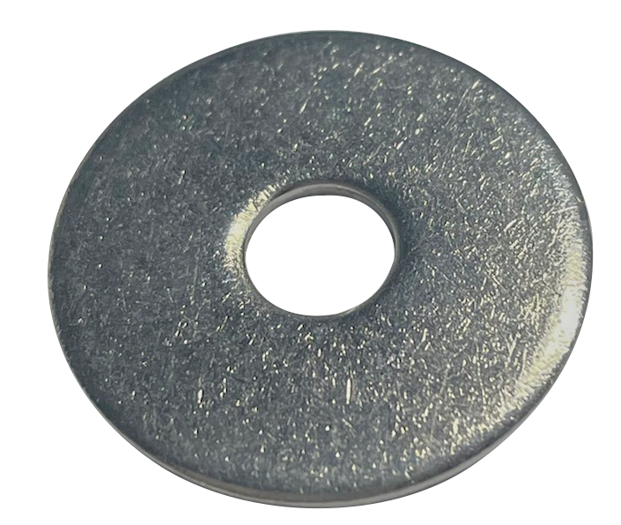
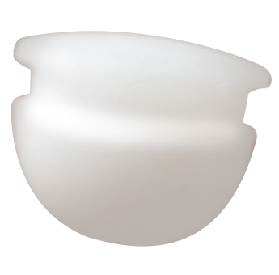
C
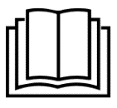
D
I
J

Tips: 1. G, H, I, and J are only for ceiling mounting.
- Heating Device x 1 | - Spacers x 4 (option)
- Hole Covers x 4 | - Manual x 1
Ceiling mounting accessories:

- Metal Expansion Tubes x 4 | - Screws x 4
- Spring Toggles x 4 | - Washers x 4
2. G and H are applied to concrete ceilings, whereas H, I and J are used on gypsum board ceilings.
5┃DEVICE STRUCTURE
⑤

Designation
②

- Heating Layer
③
④

- Aluminum frame
- Insulation Layer
- Aluminum foil cloth or Clad steel sheet
- Mounting Hole

6┃INSTALLATION
Make sure remove the protective film(on the front)!

Instruction for Wall Mounting
IMPORTANT: this way is for wall mounting only!
- Measure the distance of four holes on each frame of heating panel
and mark four punch points onto the wall. Drill four 6mm holes on the wall, make sure the positions are correct.
- Insert the Yellow Dowels(E) into the holes by a hammer
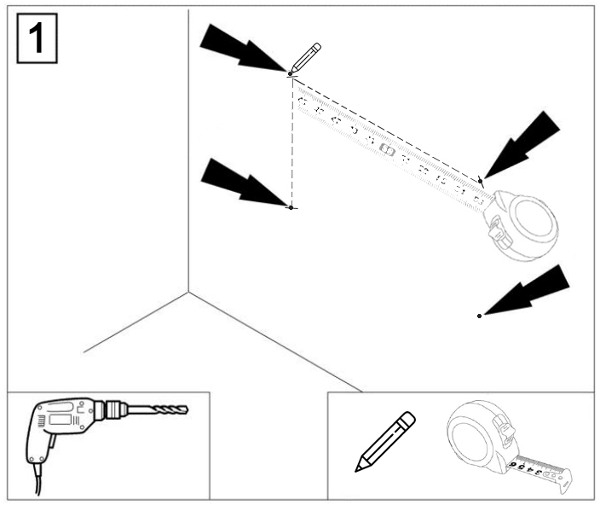
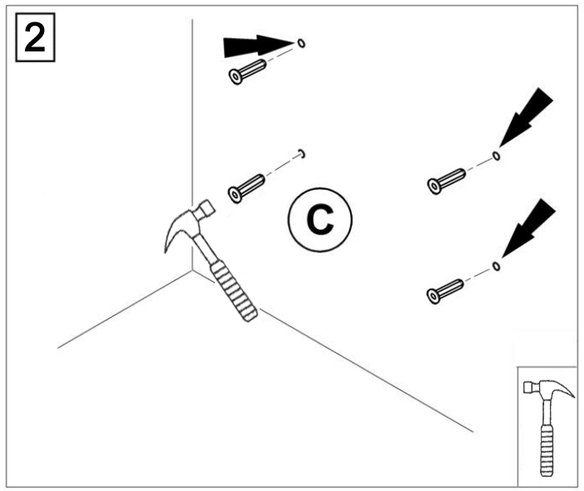

E

- Insert the Self-tapping Screws (F) through the mounting holes and spacer in turn, and spacer should be placed behind the panel (If you have not purchase spacer, you do not need to place it) , then screw into the Yellow Dowels.
- Cover the naked holes with the hole covers.
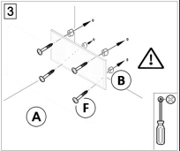
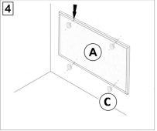

Instruction for Ceiling Mounting way A:
Please ensure the ceiling can withstand the weight of the product
first！
- Measure the distance of four holes on each frame of heating panel
and mark four punch points onto the ceiling.
- Make sure to determine the material of the ceiling. The following are the installation methods for concrete ceilings and gypsum board ceilings. Please choose and use appropriate accessories based on the specific situation.
- Concrete ceiling Installation
Step1:Drill four 10mm holes at the marked positions.
Excessive drilling diameter is strictly prohibited !
Step2: Insert the metal expansion tubes(G) into the drilled holes.
Step3:Thread screws(H) sequentially through the frame holes and spacers (if spacers are not purchased, there is no need to place them). The spacers should be positioned behind the panel, and then tighten the screw into the metal expansion tube.
Turn the screws to the end tightly, This is very IMPORTANT!
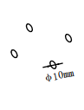
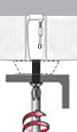
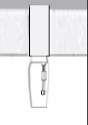
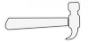
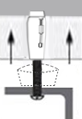
G
H
B

- Gypsum boards ceiling Installation
Step1:Drill four 18mm holes at the marked positions.
- Excessive drilling diameter is strictly prohibited !
- Please note that the spring toggles(I) are designed for
gypsum boards or wooden ceilings with a thickness ranging from
9-18mm. It is forbidden to be used on gypsum board ceilings with a thicknesses less than 9mm.
- For wooden ceilings exceeding 18mm in thickness, consider
employing metal expansion tubes (G) or using your own carpentry nails, ensuring the carpentry nails meet or exceed M5*40mm in size.
Step2:Thread screws(H) sequentially through the frame holes, spacers, washers, and spring toggles (if spacers are not purchased, there is no need to place them). Then, insert the spring toggles into the pre-drilled holes.

Step3:Tighten the screws .
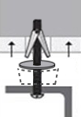
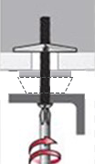
I

Φ18mm
J
B

H

- Cover the naked holes with the hole covers.
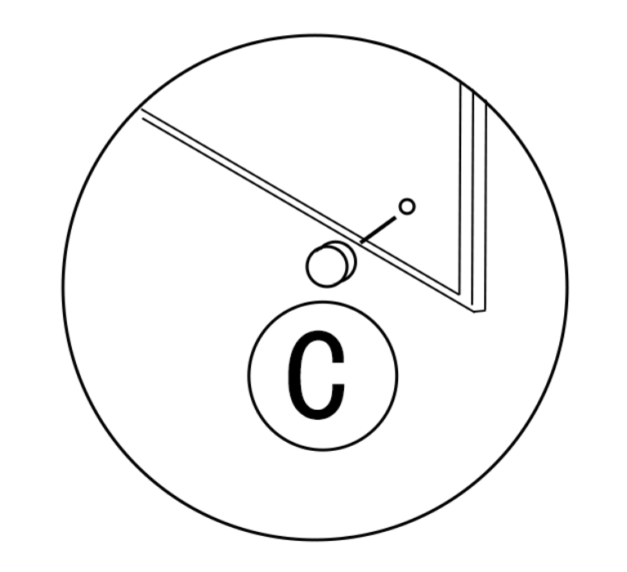

C

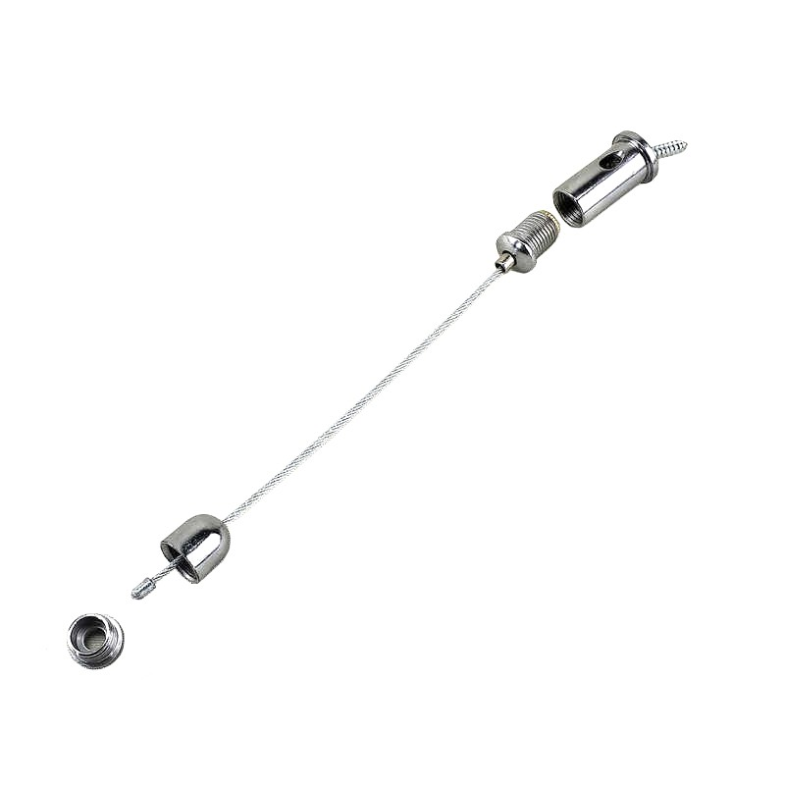
Instruction for Ceiling Mounting way B:
Only if below ceiling mounting wire sets included.

O

M
N
K

L
P

- Drill four 2mm diameter holes on the rear of the panel frame if there are no such small holes exists. Insert short screws(P) through 'L' and screw them into the frame holes with a screwdriver.
Note: Avoid using power tools as excessive torque can cause the screws
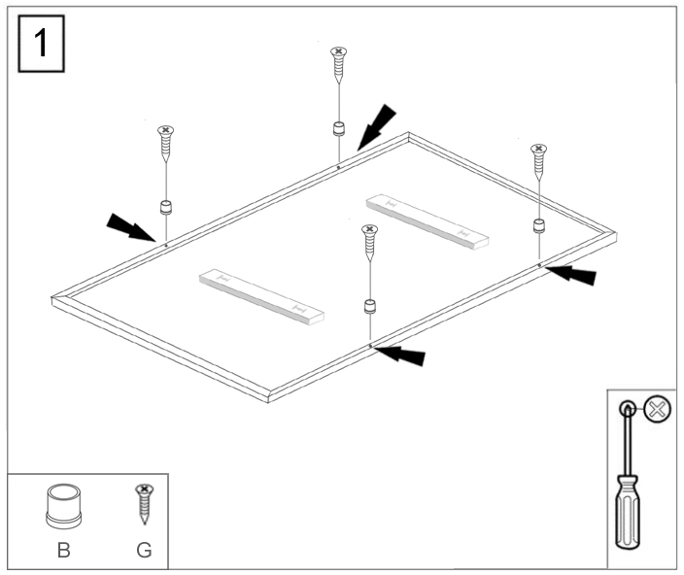
to slip!

- Tighten wires 'K' to 'L' by screwing 'M'.
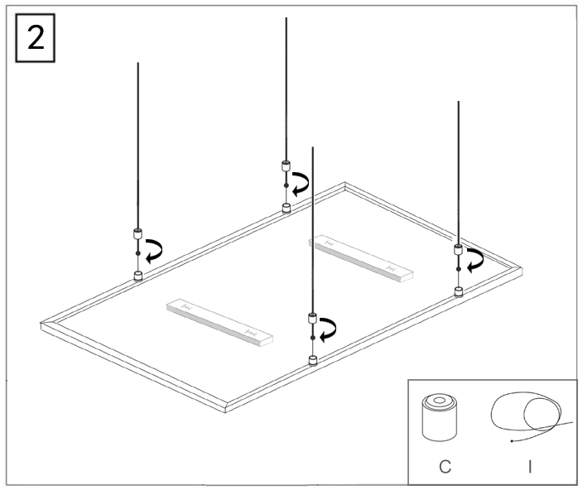

- Concrete ceilings use metal expansion tubes(G), and gypsum board ceilings use spring toggles(I).
- Thread screws(H) through the metal component(O), then screw it into the metal expansion tubes(G) or the spring toggles(I), and tighten the screw.
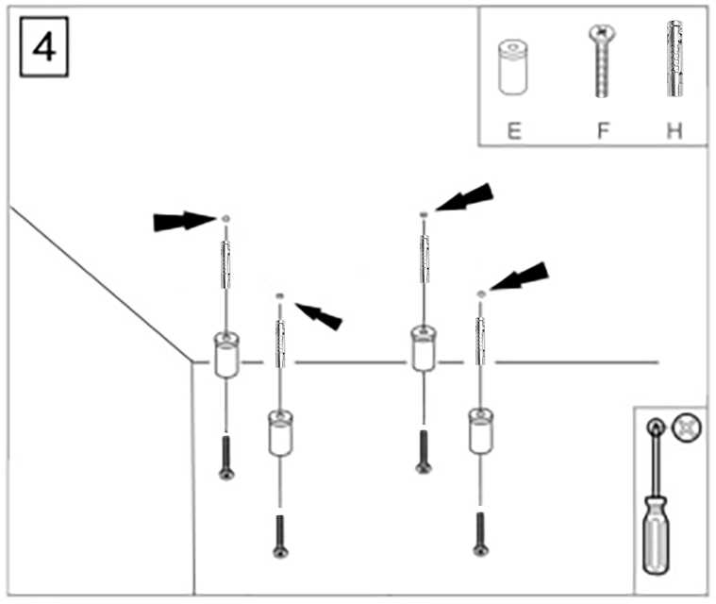
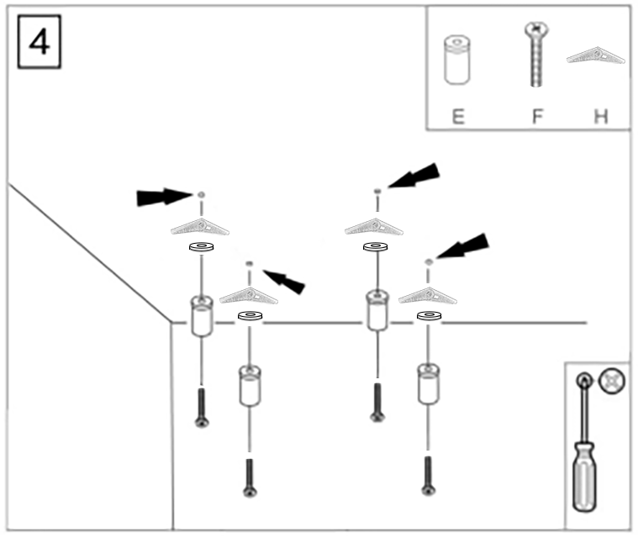

or

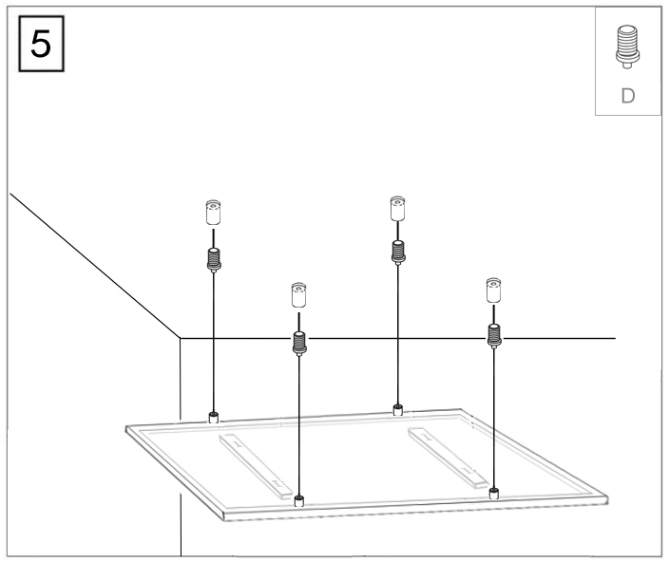
- Screw component(N) from the other end of the steel wire rope(K) into the metal component(O) and tighten it.

- Press the automatic locking extractor to adjust the desired length of the steel wire.
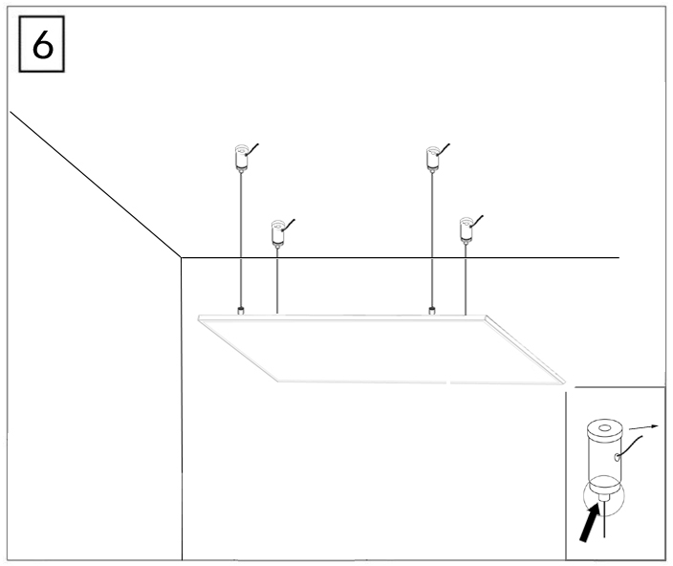
Release the locking extractor, then it will lock the wire automatically.

7┃TROUBLESHOOTING

Problem | Reason | Measure
It has noise when original charged with electricity | Due to the structure stress of the heat insulator. | It is a normal phenomenon.  Don't worry about it.
The surface of the device was slightly raised. | Due to the thermal expansion of the surface material. | It is a normal phenomenon.  Don't worry about it.
The surface of the heating device is slightly warm. | 1. The voltage is low.  2. In a low-temperature environment. | 1. Install a voltage regulator.  2. It is normal.

8┃MAINTENANCE & SERVICING

Activities required before starting maintenance
Warning of electrical voltage
Do not touch the mains plug with wet or damp hands.
• Hold onto the mains plug while pulling the power cable out
of the mains socket.
• Allow the device to cool down completely.
Warning of electrical voltage
Tasks which require the housing to be opened
must only be carried out by authorized specialist
companies.
Cleaning the device
Warning of electrical voltage
Never immerse the device in water!
Clean the device with a soft, damp and lint-free cloth. Ensure
that no moisture enters the housing. Protect electrical
components from moisture. Do not use any aggressive cleaning
agents such as cleaning sprays, solvents, alcohol-based or
abrasive cleaners to dampen the cloth.
Wipe the housing dry after cleaning

9┃STORAGE
When the device is not being used, observe the following storage conditions:
• dry and protected from frost and heat
• in an upright position where it is protected from dust and
direct sunlight
• with a cover to protect it from invasive dust, if necessary
• Place no further devices or objects on top of the device to
prevent it from being damaged.

10┃DISPOSAL
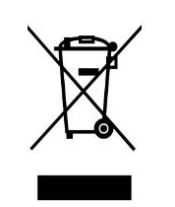

The icon with the crossed-out waste bin on waste
electrical or electronic equipment stipulates that this equipment
must not be disposed of with the household waste at the end of
its life. You will find collection points for free return of waste
electrical and electronic equipment in your vicinity. The
addresses can be obtained from your municipality or local
administration.
The separate collection of waste electrical and electronic
equipment aims to enable the re-use, recycling and other forms
of recovery of waste equipment as well as to prevent negative
effects for the environment and human health caused by the
disposal of hazardous substances potentially contained in the
equipment.

