PANEL HEATER

INSTRUCTION MANUAL

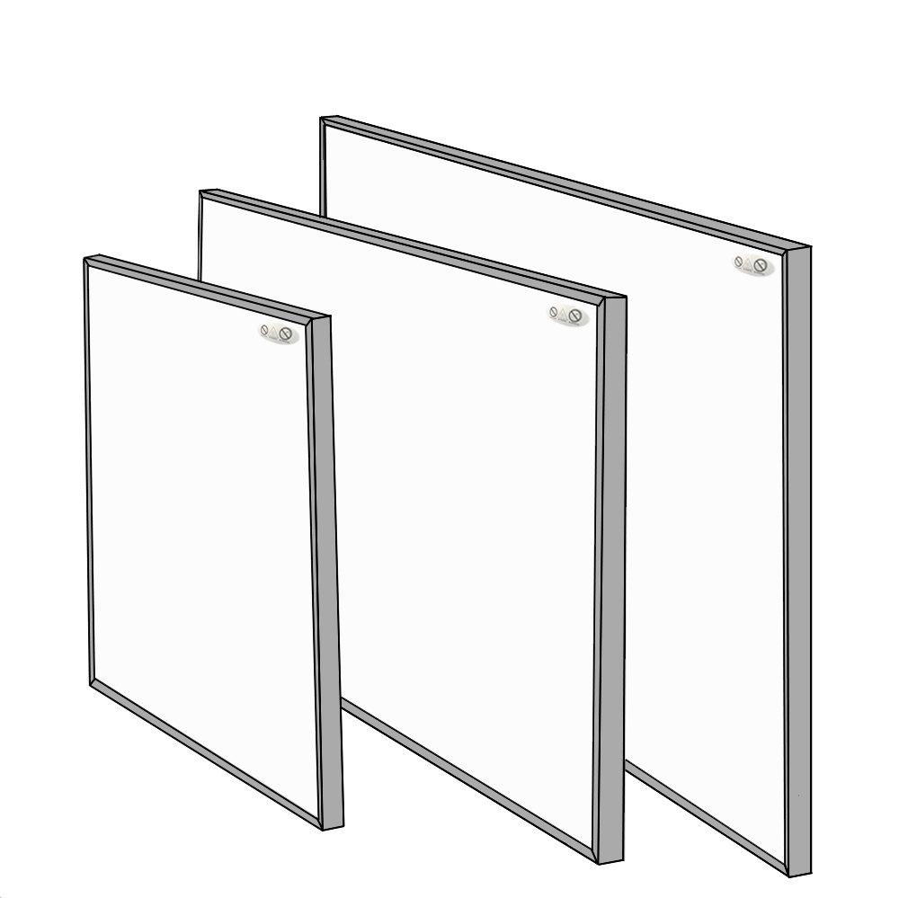


Instruction for Ceiling Mounting Way A:
Only if below ceiling mounting sets included.
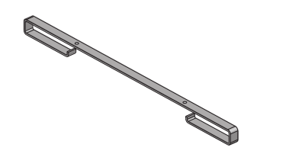

X 2 SETS

- Drill two holes on the ceiling with correct distance A and distance
B.
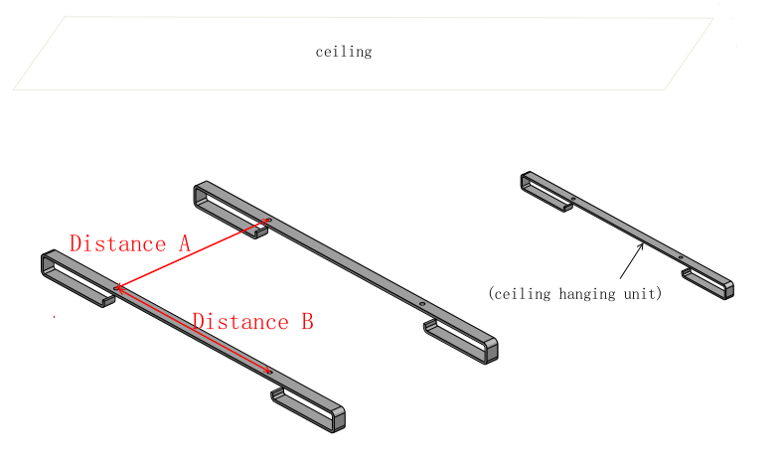

Panel Size/mm | Hole Distances of Screws/mm
605*605 (or similar) | A310*B240mm
705*605 (or similar) | A360*B240mm
805*605 (or similar) | A480*B240mm
905*605 (or similar) | A480*B240mm
1005*605 (or similar) | A480*B240mm
1205*605 (or similar) | A660*B240mm
1205*755 (or similar) | A660*B390mm
1205*805 (or similar) | A660*B390mm
1205*905 (or similar) | A660*B470mm
1205*1005 (or similar) | A660*B470mm

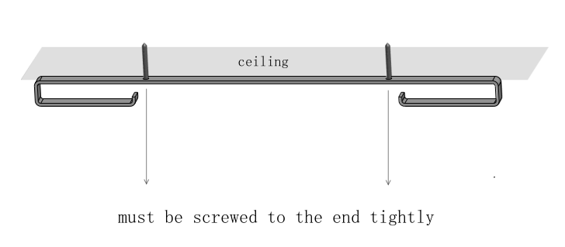
- Mount the two hanging units onto ceiling with screws, and turn
the screws to the end tightly, this is very important.

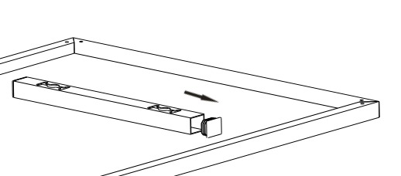
- Take off all the four plastic caps from rear of the panel

- Slide the panel to make ceiling hanging units into one side of the
panel rear bracket first, then push the whole panel close to ceiling
and slide the panel back, to make the other end of the ceiling
hanging unit enters the other side.
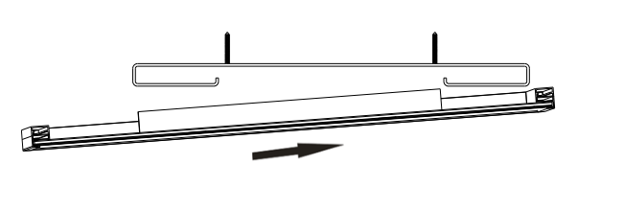

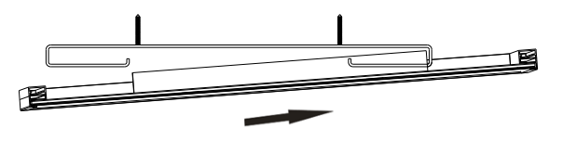

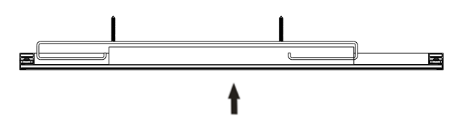
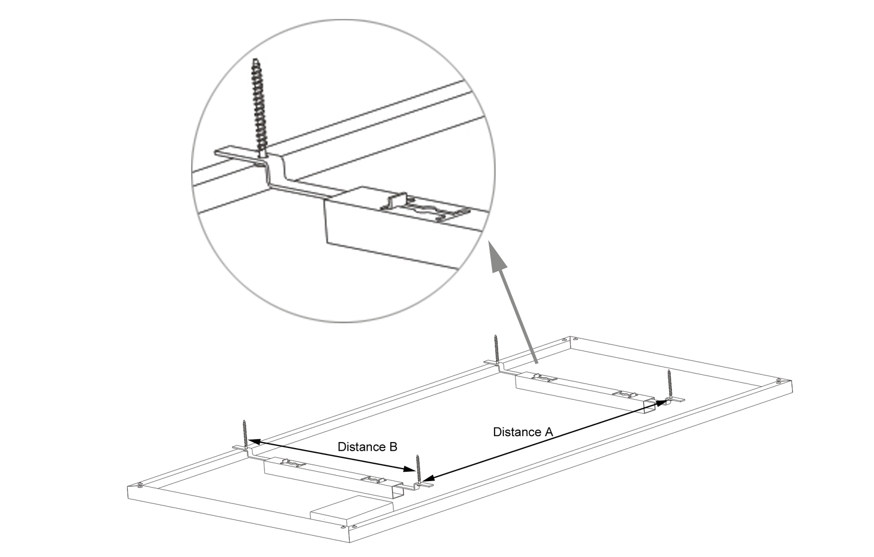

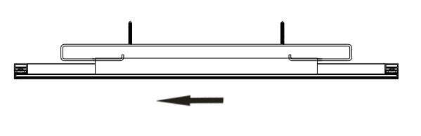

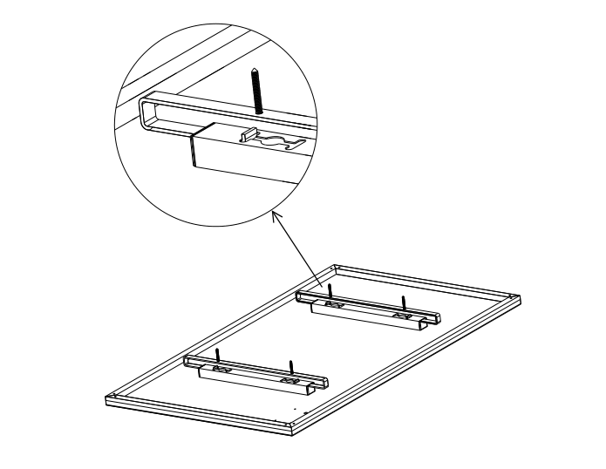

(View after mounting finished)

