CEILING PANEL HEATER

INSTRUCTION MANUAL

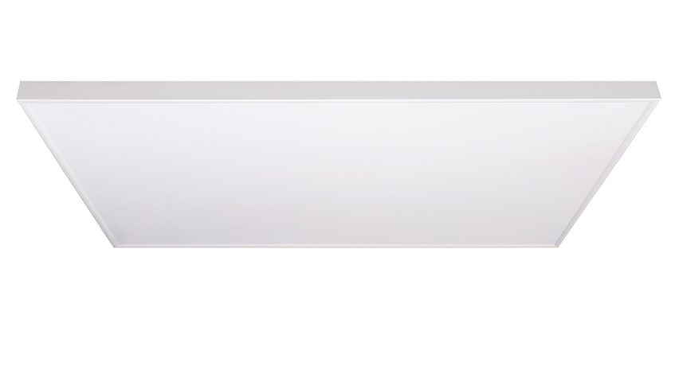




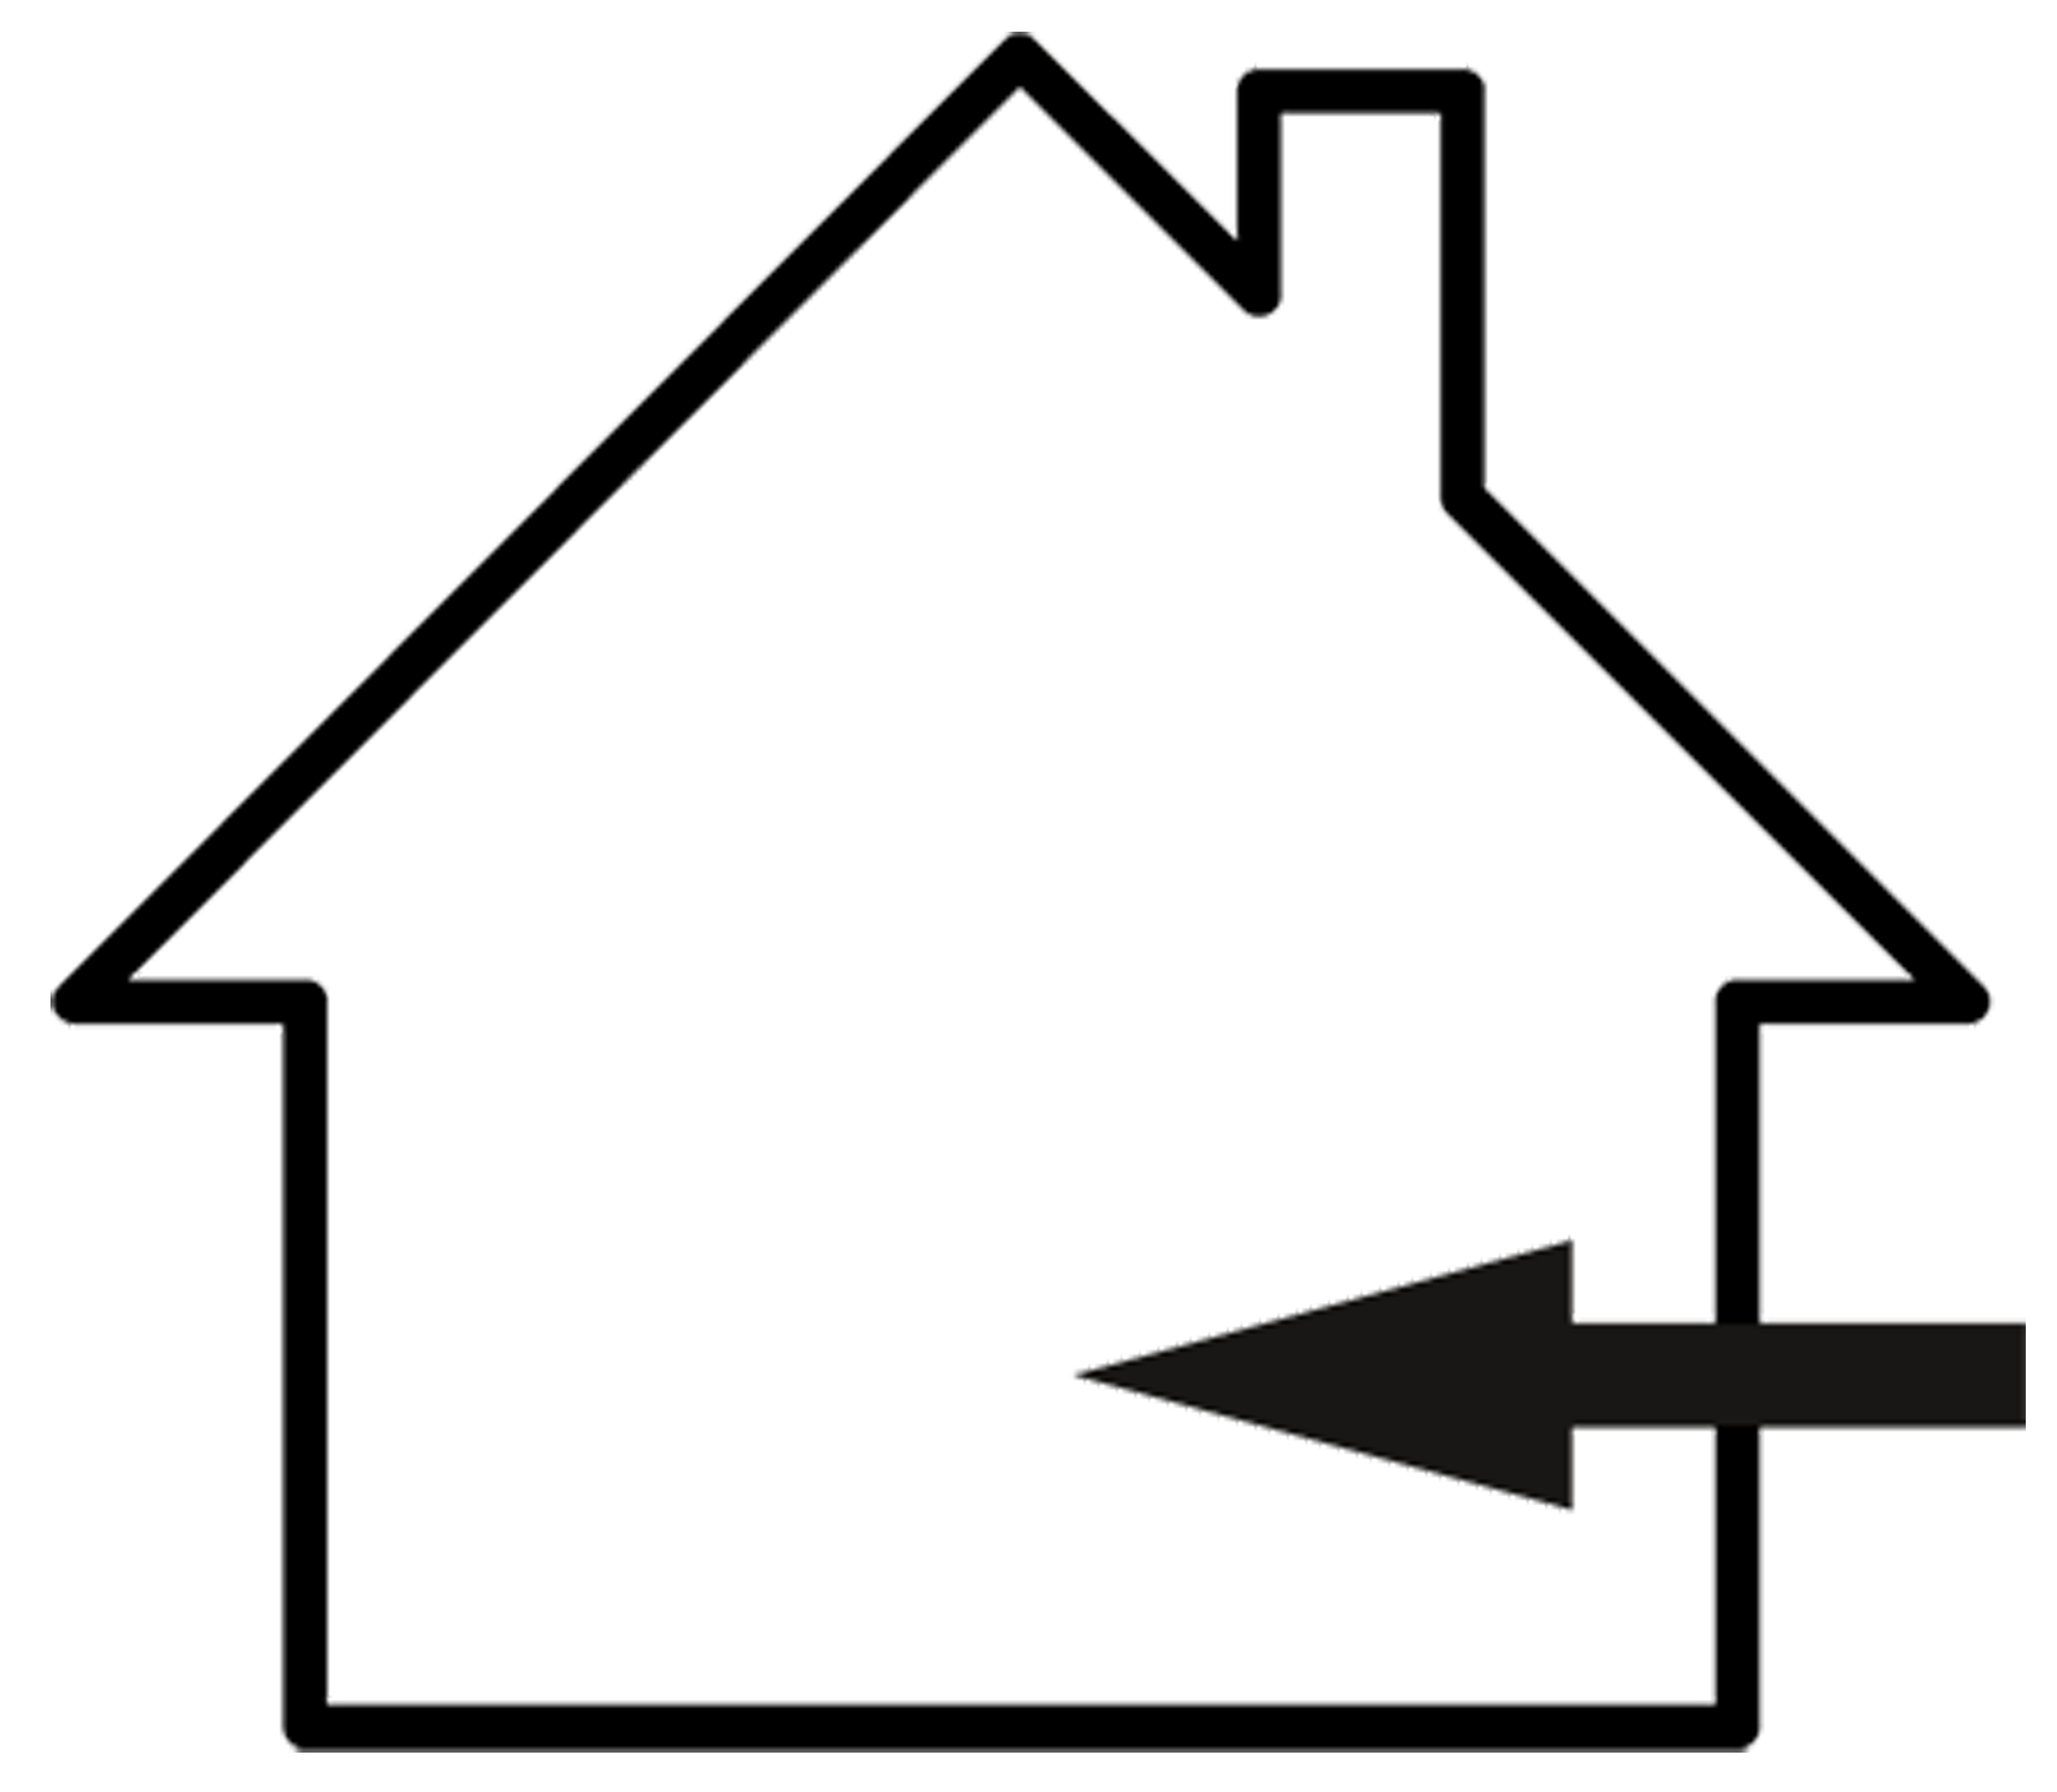

SYMBOLS

Warning
This signal word indicates a hazard with an average
risk level which, if not avoided, can result in serious
injury or death.

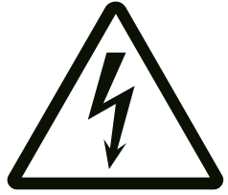Warning of electrical voltage
This symbol indicates dangers to the life and health of
persons due to electrical voltage.

Symbols | Meaning
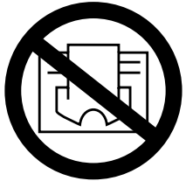 | This symbol located on the device indicates that it is  prohibited to place objects (such as towels, clothes etc.)  above or directly in front of the device.In order to avoid overheating and fire hazards, the device must not be covered.

CONTENT

1┃WARNING & PRECAUTION 2┃FEATURES 3┃TECHNICAL INFORMATION

4┃SCOPE OF SUPPLY 5┃DEVICE STRUCTURE 6┃INSTALLATION 7┃TROUBLESHOOTING 8┃MAINTENANCE & SERVICING

9┃STORAGE

10┃TECHNICAL ANNEX
11┃DISPOSAL
12┃OPTIONAL CONTROL MODES (Additional instructions)

1┃WARNING & PRECAUTION
Read this manual carefully before starting or using the
device. Always store the manual in the immediate vicinity
of the device or its site of use!

Read all safety warnings and all instructions.
Failure to follow the warnings and instructions may result in electric shock, fire and / or serious injury. Save all warnings and instructions for future reference.
Warning
This series must be mounted above 1.8meters high！
Make sure the series you bought and install it in accordance to the tips in installation part!
Warning
This appliance can be used by children aged from
8 years and above and persons with reduced physical,
sensory or mental capabilities or lack of experience
and knowledge if they have been given supervision or
instruction concerning use of the appliance in a safe
way and understand the hazards involved.
Children shall not play with the appliance. Cleaning and
user maintenance shall not be made by children
without supervision.
Warning
Children of less than 3 years should be kept away
unless continuously supervised.
Children aged from 3 years and less than 8 years shall
only switch on/off the appliance provided that it has
been placed or installed in its intended normal
operating position and they have been given
supervision or instruction concerning use of the
appliance in a safe way and understand the hazards
involved.
Children aged from 3 years and less than 8 years shall
not plug in, regulate and clean the appliance or
perform user maintenance.
Warning
Do not use the device in small rooms if persons are
present who cannot leave the room independently and
who are not under constant supervision.
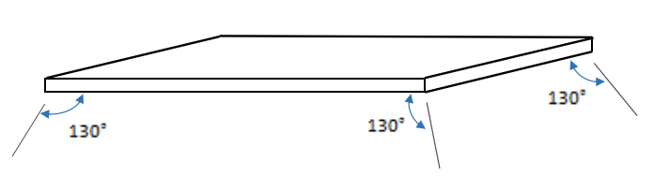
Warning
Sensors with temperature detection, or temperature controller, should not be placed within the radiation range of 130 degrees of the ceiling heating plate, otherwise it will affect the actual temperature detection .
Warning
Some parts of this product can become very hot and cause
burns. Particular attention has to be given where children
and vulnerable people are present. Its dangerous of
installation close to curtains and other combustible
materials. To avoid the possibility of burns, the following
people should be much more careful when using the
heaters: infants and kids, people with sensitive skin, the
old, the sick, people who is drunk, people who takes sleeping
pills.
• Remove the protective film(on the front) before using.
• Be sure the usage voltage is between 220-240V, 50Hz, and power supply has been strictly in accordance with IEC, left is null wire and right is live wire, and also well grounded.
• The devices will draw more current than small appliances, so a separate 5A socket is required.
• Do not use the device in potentially explosive rooms.
• Do not use the device in aggressive atmosphere.
• Set the device up in an upright and stable position.
• Let the device dry out after a wet clean. Do not operate it
when wet.
• Do not use the device with wet or damp hands.
• Do not expose the device to directly squirting water.
• Never insert any objects or limbs into the device.
• Do not cover or transport the device during operation.
• Do not sit on the device.
• This appliance is not a toy! Keep away from children and animals. Do not leave the device unattended during operation.
• Check accessories and connection parts for possible damage prior to every use of the device. Do not use any defective devices or device parts.
• Ensure that all electric cables outside of the device are protected from damage (e.g. caused by animals). Never use the device if electric cables or the power connection are damaged!
• The electrical connection must correspond to the specifications in chapter Technical data.
• Insert the mains plug into a properly secured mains socket.
• Do not use the device when the socket or wire overloaded.
• Observe the device's power input, cable length and intended use when selecting extensions to the power cable. Completely unroll extension cables. Avoid electrical overload.
• Before carrying out maintenance, care or repair work on the device, remove the mains plug from the mains socket. Hold onto the mains plug while doing so.
• Switch the device off and disconnect the power cable from the main socket when the device is not in use.
• Do not use the device under any circumstances if any damages on the mains plug or power cable. If the supply cord is damaged, it must be replaced by the manufacturer, its service agent or similarly qualified.
persons in order to avoid a hazard. Defective power cables pose a serious health risk.
• During the installation of the device observe the minimum distances from walls and other objects as well as the storage and operating conditions specified in the Technical data chapter.
• Never drill into the heating device.
• Do not use the device in immediate proximity to curtains.
• Do not place the device on combustible ground.
• Do not transport the device during operation.
• Do not touch the surface during the device working to avoid burns.
• Allow the device to cool down before transport and / or maintenance work.
• Do not use this device near bathtubs, shower trays, swimming pools or other water containers. Risk of electric shock!
• The device must be placed where the switches and controllers cannot be touched by a person in a bathtub or shower.
• Do not use this device in a child-care centre and bathroom.(Only for Sweden)

2┃FEATURES
• The device is designed to provide an efficient, comfortable and
healthy heating system for any domestic users.
• These devices can reduce air circulation and help to maintain a
clean, silent, dust free environment.
• A wide range of devices available in a huge choice of colors, sizes and styles.

3┃TECHNICAL INFORMATION

4H series
Heating element | Carbon
Heating way | Far infrared heating
Input Voltage | 220-240V/50Hz
Surface temperature | Main 130-150℃
Frame | Aluminum
Power cord length | ≤1.9m

Model NO. | Size(mm) | Power  (W)
4H-0606 | 595*595*35 | 400W
H4-0606 (with thermostat) | 595*595*35 | 400W
4H-1006 | 1005*605*35 | 660W
4H-1006 (with thermostat) | 1055*605*35 | 660W
4H-1206 | 1195*595*35 | 860W
4H-1206 (with thermostat) | 1195*595*35 | 860W

4┃SCOPE OF SUPPLY
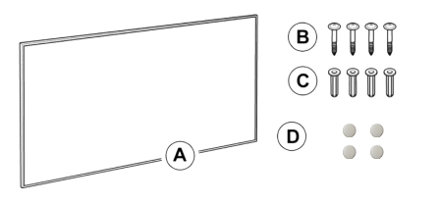
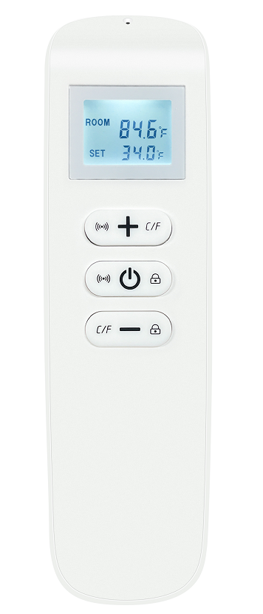
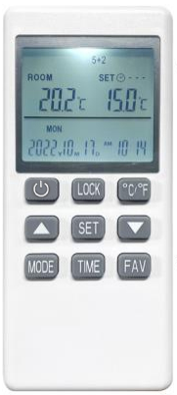
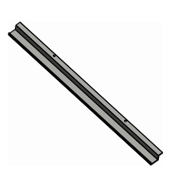

OR

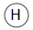


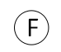
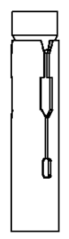

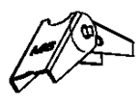
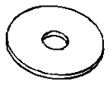

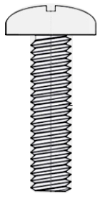
A: Heating Device ×1 | B: Hanging Units × 2
C: Metal Expansion Tubes × 4 | D: Screws × 4
E: Spring Toggles × 4 | F: Washers × 4
G: Screws × 2 | H: Thermostat × 1
I: Manual × 1
Tips: C and D are applied to concrete ceilings, whereas D, E and F are used on gypsum board ceilings.

5┃DEVICE STRUCTURE

Front
Rear
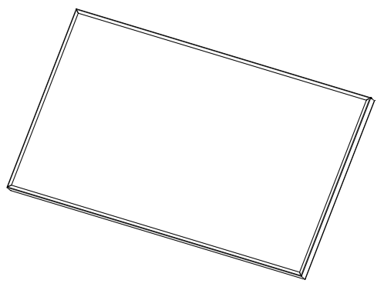
power cord
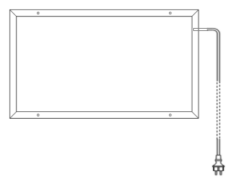

front surface

limit screw

power cord plug (optional)

6┃INSTALLATION
Warning
• Mounting work must be carried out by professional electrician !
• Power input cords must be wired to those lines with switches which can freely cut off the live lines!
• Do power off all lines which are to be wired with the power input cord before mounting and wiring.
• Power input cords must be well grounded!
• Do not suspend panels by heating power cord or power input cord!
• No any sticking ways are allowed to be used for hanging or suspending support !
• Do remove the front protective film before using !

Common roof installation method A
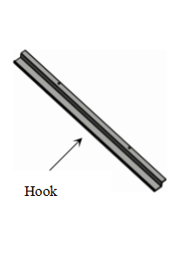
Before starting the installation, please make sure to determine the material of the ceiling. The following are the installation methods for concrete ceilings and gypsum board ceilings. Please choose and use appropriate accessories based on the specific situation.
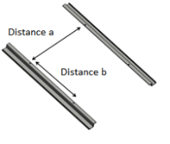

- Concrete ceiling Installation
Panel Size/mm | Hole Distances of Screws/mm
595*595 (or similar) | a485*b100mm
1005*605 (or similar) | a495*b300mm
1055*605 (or similar) | a495*b300mm
1195*595 (or similar) | a485*b300mm
Step1: Measure and mark the correct distances "a" and "b" on the concrete ceiling where you want to install.
Step2:Drill four 10mm holes at the marked positions.
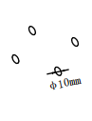
Φ10mm
Excessive drilling diameter is strictly prohibited !

Step3: Insert the metal expansion tubes(C) into the drilled holes.
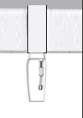
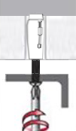

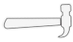

Step4: Thread screws(D) through the hanging units(B) holes, then tighten them into the tubes.
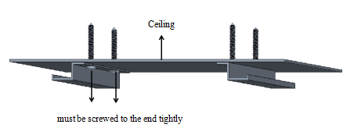
Turn the screws to the end tightly, This is very IMPORTANT!

- Gypsum boards ceiling Installation
Step1: Measure and mark the correct distances "a" and "b" on the concrete ceiling where you want to install.
- Please note that the spring toggles (E) are designed for gypsum
boards or wooden ceilings with a thickness ranging from 9-18mm.
It is forbidden to be used on gypsum board ceilings with a thicknesses less than 9mm.
- For wooden ceilings exceeding 18mm in thickness, consider employing metal expansion tubes (C)or using your own carpentry nails, ensuring the carpentry nails meet or exceed M5*40mm in size.
Step 2: Drill four 18mm holes at the marked positions.
Excessive drilling diameter is strictly prohibited !
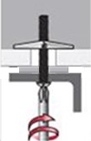
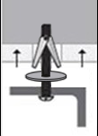
Step 3: Thread screws(D) through the hanging units(B) holes, washers(F) and spring toggles(E), and then insert the spring toggles(E) into the pre-drilled holes.

Φ18mm

Step4: Tighten the screws .
Install the Heating Device (A) after completing installation of a or b
- Push the rear of the left long frame into the hook, and then push back to make the rear of the right long frame into the other hook.
Note: Hooks are for the two long frames only, not the two short ones!

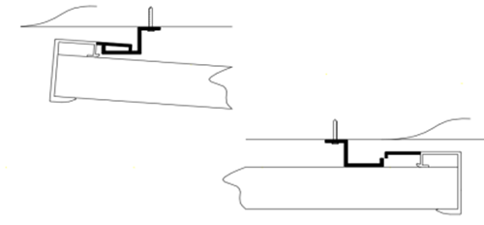
Ceiling

PUSH
Panel
Left long frame

PUSH
Panel
Right long frame

- To avoid falling off, you must slide the panel left and right to make sure the two hooks have been completely put into the rear of the two long frames!
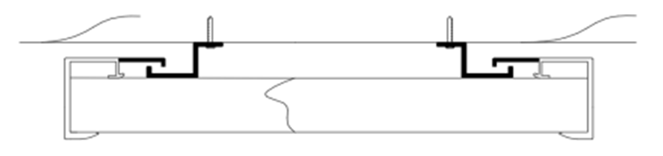

PUSH
PUSH

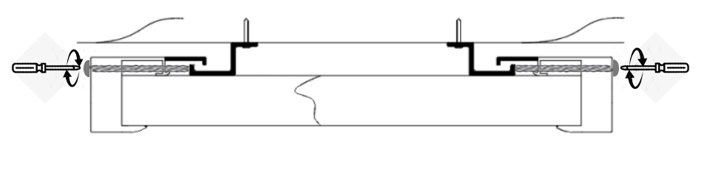
- Screw the screws(G) into the holes reserved on both sides of the product and tighten.

Integrated ceiling installation method B
1. Tilt the heater over the ceiling through the reserved mounting hole .
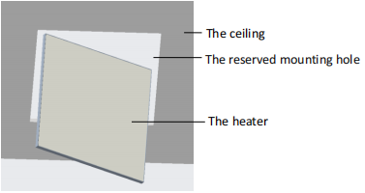
Note: Pay attention to the space between the integrated ceiling and the roof. If the space is too small, it may not fit.

2. Level the heater so that the heating side is facing down
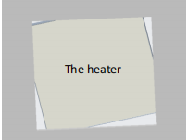

- Connect the power cord or plug it into the socket.
Note: Please finish the Wi-Fi setting before making the heater in place, otherwise the indicator light in the frame side will be not visible.
4. Drop the heater into the ceiling mounting slot.
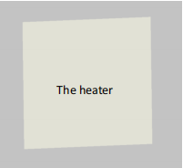

7┃TROUBLESHOOTING

Problem | Reason | Measure
It has noise when original charged with electricity | Due to the structure stress of the heat insulator. | It is a normal phenomenon.  Don't worry about it.
The surface of the device was slightly raised. | Due to the thermal expansion of the surface material. | It is a normal phenomenon.  Don't worry about it.
The surface of the heating device is slightly warm. | 1. The voltage is low.  2. In a low-temperature environment. | 1. Install a voltage regulator.  2. It is normal.

8┃MAINTENANCE & SERVICING
Activities required before starting maintenance
Warning of electrical voltage
Do not touch the mains plug with wet or damp hands.
• Hold onto the mains plug while pulling the power cable out
of the mains socket.
• Allow the device to cool down completely.
Warning of electrical voltage
Tasks which require the housing to be opened
must only be carried out by authorized specialist
companies.
Cleaning the device
Warning of electrical voltage
Never immerse the device in water!
Clean the device with a soft, damp and lint-free cloth. Ensure
that no moisture enters the housing. Protect electrical components from moisture. Do not use any aggressive cleaning agents such as cleaning sprays, solvents, alcohol-based or abrasive cleaners to dampen the cloth. Wipe the housing dry after cleaning
9┃STORAGE
When the device is not being used, observe the following storage conditions:
• dry and protected from frost and heat
• in an upright position where it is protected from dust and
direct sunlight
• with a cover to protect it from invasive dust, if necessary
• Place no further devices or objects on top of the device to
prevent it from being damaged.

10┃TECHNICAL ANNEX
Information requirements for electrical local space heaters
11┃DISPOSAL
Item | Unit
Type of heat input, for electric storage local space heaters only (select one)
manual heat charge control, with integrated thermostat | [no]  N/A
manual heat charge control with room and/or outdoor  feedback  temperature feedback | [no]
electronic heat charge control with room and/or outdoor  feedback  temperature feedback | [no]
fan assisted heat output | [no]  N/A
Type of heat output/room temperature control (select one)
single stage heat output and no room temperature control | [no]  [no]
Two or more manual stages, no room temperature control | [no]  [no]
with mechanic thermostat room temperature control | [no]  [no]
with electronic room temperature control | [no]  [no]
electronic room temperature control plus day timer | [no]  [no]
electronic room temperature control plus week timer | [yes]  [yes]
Other control options (multiple selections possible)
room temperature control, with presence detection | [no]  [no]
room temperature control, with open window detection | [yes]  [no]
with distance control option | [no]  [yes]
with adaptive start control | [no]  [no]
with working time limitation | [yes]  [yes]
with black bulb sensor | [no]  [no]
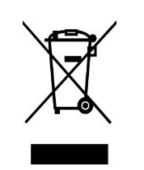

The icon with the crossed-out waste bin on waste
electrical or electronic equipment stipulates that this equipment
must not be disposed of with the household waste at the end of
its life. You will find collection points for free return of waste
electrical and electronic equipment in your vicinity. The
addresses can be obtained from your municipality or local
administration.
The separate collection of waste electrical and electronic
equipment aims to enable the re-use, recycling and other forms
of recovery of waste equipment as well as to prevent negative
effects for the environment and human health caused by the
disposal of hazardous substances potentially contained in the
equipment.

12┃OPTIONAL CONTROL MODES (Additional instructions)
This product has 3 control modes to choose from
A | Use common switch Type 86 ≥10 A control mode
B | With built-in remote thermostat control mode
C | With built-in WIFI and remote thermostat control mode
A: Instruction for Control and Operation Way A
Use common switch Type 86 controller ≥10 A
B: Instruction for Control and Operation Way B
Thank you for choosing infrared heating panel with built-in thermostat, Please take time to read and understand this manual so you can begin to enjoy the convenience and energy saving benefits of this product.
Technical Data of Remote-Controller
- Battery-powered: DC 3V(2x 1.5V AAA batteries, not included)
- Power Consumption: 3V,0.1mA
- Set temperature range: 5℃~ 35℃, resolution: 1℃
- Room temperature range: 0℃~ 50℃, display resolution: 0.1℃
- Accuracy of the measured temperature: ±0.5℃
- Working environment range 1℃~ 50℃
- Dimension: L135mm×W56mm×H18mm
- Weight: 86g
- Radio frequency 433.92MHz
- Technical Data of Built-in Receiver
- Power Supply:AC220-240V,50/60 Hz
- Power Consumption:0.4W
- With remote control disabling switch at the rear of the heater
INTRODUCTION
- Each set consists of two parts:A remote-controller with digital display, which accommodates the electronics, the operating elements and the built-in room temperatures sensor.built-in receiver, which can receive and decode signal from the remote-controller .
- The remote-controller acquires the room temperature with its integrated sensor and transmit signal to the receiver to turn on/off heating device as the ambient temperature changing, in order to maintain a constant room temperature. When the ROOM temperature is 0.5℃ higher than the SET temperature, remote-controller will send OFF commands to receiver; When the ROOM temperature is 0.5℃ lower than the SET temperature, remote-controller will send ON commands to receiver, the connected heating device will be in working status to warm the house.
- The display shows the setting temperature as well as the measured temperature, time, date, modes etc.
- The remote-controller has week programmable、temperature setting、favorite temperature 、time setting functions etc.
- The remote-controller is powered by 2pcs of 1.5V AAA battery. Please change with new batteries if the battery symbol gets flashing, or else the remote will not be able to control the heaters.
- Keypad locking function is designed to prevent the children from misusing.
- The LCD screen only can work in temperature range from 1℃~ 50℃.
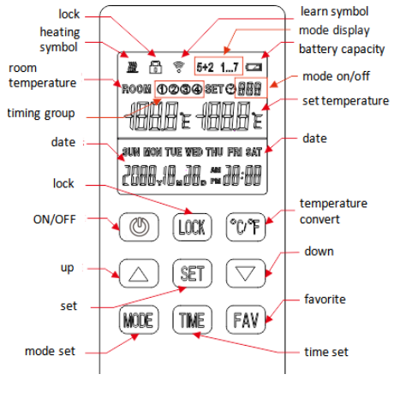


OPERATION AND SETTING
- Power on the heater, press button on the remote-controller, then press button ℃/℉ and MODE buttons at same time to pair the remote-controller and receiver until long beep sound.
NOTES:
1) Pairing shoud be finished within 1 minute, or else you need to re-power on the heater.
2) Please re-power on the heater if you want to pair with another remote-controller.
3) Before pairing please do power off those heaters which you don’t want to pair.
4) Switch on receiver ON means it will disable the remote-controller. Do not turn it on if you want to control the heater by the remote-controller.
- Press button on remote-controller to turn on/off the heater.
Note: If you press button on the remote-controller to shut down or the weekly shutdown time arrives, the display screen of the remote-controller will only show room temperature and OFF, which only means that the receiver has turned off the heater, not that the remote-controller itself has stopped working, and its internal time and temperature are still calculated. And pressing button again or weekly startup time arrives will signal the receiver to turn on the heater.
- Long press LOCK 3 seconds to lock/unlock the buttons.
- Press ℃/℉ button to convert the temperature display measurement unit.
- Long press TIME 3 seconds to set year, month, date and time with UP and DOWN buttons.
- Press UP and DOWN to set target temperature.
Even during weekly timer on period, users can also press UP and DOWN to set a temporary temperature, and only the current time period is affected.
Tips:
- The default setting temperature when the product starts up is 19°C
(in manual mode).
- Setting temperature range: 5-35℃.
- Press and hold FAV for 3 seconds until the setting temperature icon flashes, the default preferred temperature value is 24℃，which can be adjusted by pressing the ▲ and ▼ buttons, and short press FAV button to confirm.
In daily use, setting temperature will convert to favorite temperature
When short press FAV button, short press again to switch back to the
Original setting temperature.
- Default to manual mode, long press MODE button to switch to 5+2 mode, long press MODE button again to switch to 1...7 mode, long press MODE button again to switch back to manual mode, and repeat the cycle.
- Long press the SET button to enter the programming mode setting state.
(Long press again to exit)
Notes:
- Programming mode has a time-out limit whereby if no buttons are pressed within 8 seconds, it reverts back to the main screen.
- It must be set in 5+2 or 1-7 programming mode. In manual mode, long pressing SET button has no response.
- 5+2 Programming Mode
You can program the thermostat to fit your lifestyle — week and weekend, plus up to 4 groups of time interval
per day.
Step 1. Once in 5+2 mode, Press and hold the SET button for 3-5 seconds until
Program icon ① and MON TUE WED THU FRI is displayed with ON and Time Icon flashing on screen.
Step 2. Press ▲ button to adjust hour(+1hour/press) and press ▼ to adjust Minute(+5minutes/press) to set the starting time of Program ①.
Step 3. Press the SET button once and OFF icon flashing on screen, Use ▲ Button to adjust hour(+1hour/press) and press ▼ to adjust minute (+5minutes/press) to set the ending time of Program ①.
Step 4. Press the SET button once again and set temperature icon flashing on screen, Use ▲ or▼ button to set the desired temperature to be maintained for program ①.
Tips:
- Setting temperature range:5-35℃
- Short press the FAV button to choose your favorite temperature
value.
Step 5. Press the SET button to bring up Program ② of week days , repeat Step 2-5. And users can set up Program ③ and ④ in similar manner.
Step 6. After finishing setting Program ④, press the SET button to bring up SAT and SUN setting, repeat step 2-5 to set Program① ② ③ ④ of weekends.
- 1-7 Programming Mode
You can program the thermostat everyday with setting 2 groups of time interval per day.
Once in 1-7 Mode, Press and hold the SET button for 3-5 seconds until Program icon ① and MON is displayed with ON and Time icon flashing on screen, users can follow the above step 2-4 to set On/Off time and desired temperature of Program ① and ② from Monday to Sunday in sequence.

Tips:
- The default starting time，the ending time，and default temperature
settings are detailed in the following table.

_{MODE} TIME |  |  | Starting time | Ending time | Default setting temperature  （℃）
5+2 | MON-FRI | 1 | 00:00 | 06:30 | 17
5+2 | MON-FRI | 2 | 06:30 | 08:45 | 19
5+2 | MON-FRI | 3 | 08:45 | 17:00 | 17
5+2 | MON-FRI | 4 | 17:00 | 22:30 | 19
5+2 | SAT-SUN | 1 | 00:00 | 08:00 | 17
5+2 | SAT-SUN | 2 | 08:00 | 14:00 | 19
5+2 | SAT-SUN | 3 | 14:00 | 17:30 | 17
5+2 | SAT-SUN | 4 | 17:30 | 23:15 | 19
1...7 | MON | 1 | 06:30 | 17:00 | 17
1...7 | MON | 2 | 17:00 | 22:30 | 19
1...7 | TUE | 1 | 06:30 | 17:00 | 17
1...7 | TUE | 2 | 17:00 | 22:30 | 19
1...7 | WED | 1 | 06:30 | 17:00 | 17
1...7 | WED | 2 | 17:00 | 22:30 | 19
1...7 | THU | 1 | 06:30 | 17:00 | 17
1...7 | THU | 2 | 17:00 | 22:30 | 19
1...7 | FRI | 1 | 06:30 | 17:00 | 17
1...7 | FRI | 2 | 17:00 | 22:30 | 19
1...7 | SAT | 1 | 08:00 | 14:00 | 19
1...7 | SAT | 2 | 17:30 | 23:15 | 19
1...7 | SUN | 1 | 08:00 | 14:00 | 19
1...7 | SUN | 2 | 17:30 | 23:15 | 19

- The device can still be turned on and off or the temperature can be set
normally during weekly timer on, and only the current time period is
affected.
- Programming groups allow running across dates.
- When programming, please don't set overlapped intervals between
workgroups. If the time periods overlaps, the group with an earlier
starting time will be executed ON first, and the group with an earlier
ending time will be executed OFF, until the next group turns ON.
- The programmed time / temperature setting will be restored with the
next program entry in the memory.
- Once finish setting up the programming mode, the thermostat will
work under programming mode ON even if the thermostat is turned
off. The heating device will be switched ON or OFF according to the
programming setting.
- The thermostat will automatically turn off the heating device if a sudden drop in temperature in the room is detected.
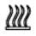
- The symbol means heating, it only displays when room temperature is 0.5℃ (or more) lower than set temperature.
- The backlight will be ON when press any button in the state of power-on.

NOTES
- The date and time need to be reset after battery replaced. No reprogramming required.
- Alkaline battery is recommended. If ALL the buttons on the remote-controller are not working, try replacing the batteries.
- Please do change the batteries with new ones once the screen battery symbol gets flashing, or else it may result in halted/stuck/not working.
- Check if set temperature higher enough than room temperature first if the heater can not be turned on by remote-controller.
- If users want the week timer and temperature work, make sure it has been switched to 5+2 or 1...7 mode;
If users want it not working, switch to manual mode.
- Do not cover or touch the temperature sensor which is at the top of the remote-controller.
- Do put the remote-controller in a open normal room environment rather not inside a drawer/pocket or under pillow/quilt etc.
- Please do take out the batteries from the remote-controller if long time no use.
C: Instruction for Control and Operation Way C
Ⅰ. Product Description
Internal WIFI thermostat are normally built in H4 series panel heaters, controlled by mobile phone through internet, function includes.
● WIFI remote control
● remote control
● temperature adjust
● weekly programme on/off and temperature setting
● count down power off
● share to other users
It works with a remote-controller which acquires room temperature and transmit signal to the heater receiver. This remote-controller has a LCD screen which can display current room temperature.
Ⅱ. Technical Data of Internal Receiver
- Power Supply: AC220-240V
- Wireless standard: IEEE802.11b/g/n
- Frequency range: 2.412~2.484GHz
- Security mechanism: WEP/WPA-PSK/WPA2-PSK
- Encryption type: WEP/TKIP/AES
- Standby power consumption: <0.8W
- Working environment: temperature -5 ~ 50 ° C; humidity 10% -95%.
Ⅲ. Technical Data of remote-controller
- Power supply: DC3V (2*1.5V AAA batteries, not included)
- Power consumption: 3V 0.1mA
- Temperature setting range:5℃~35℃
- Temperature display range: 0℃~50℃
- Maximum work distance: ＜8 meters
- Dimension: 140mm×40mm×18mm
- Weight: 40g
Ⅳ. Function of remote-controller
- Built in receiver and remote-controller constitute the temperature control system;
- The remote-controller is powered by 2pcs of 1.5V AAA battery. Please change with new batteries if the battery symbol gets flashing, or else the remote will not be able to control the heaters.
- The remote-controller acquires the room temperature through the senor on the top, and send real-time temperature data to the receiver.
- The screen can display the room temperature, setting temperature, child lock, battery level etc.
- The remote-controller has the functions of switching heater on/off, setting temperature, temperature conversion, child lock etc.
- When the screen of the remote-controller is off, it only means that the heater is off, and it does not mean that the remote-controller has stopped working. It is still detecting real-time temperature data and sending the real-time temperature data to the receiver every 60s for logical control (the remote-controller will send the collected temperature data whether it is on or off).
- One remote-controller can be paired with several heaters, users can pair them one by one or at same time together, both ways are workable.

Ⅴ. Instructions of remote-controller operation
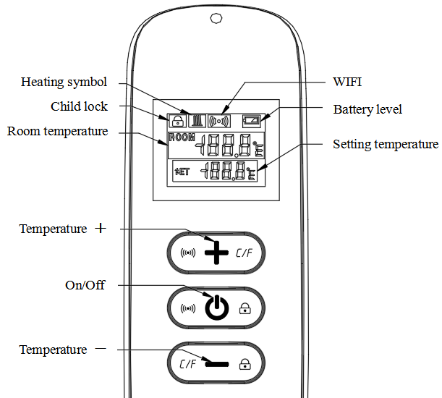

Remote-controller

- Power on the heater , and then press " " and "＋" at the same time within five minutes to start pairing , the WIFI symbol flashes three times and sends out the paring code to indicate that paring is taking place, there will be one beep sound from heater after success.
Note:1.Please turn off the heaters that you do not want to be paired before pairing .
2.If the remote control needs to be replaced, please power on the heater again, and then complete the pairing within five minutes. If the pairing is not finished within five minutes, the pairing mode will be off and you will need to repeat the above steps to pair again.
- Press " " to turn on the heater, and press again to turn off the heater.
- Press the "+" key to increase the set temperature by 1℃, press the "－" key to decrease the set temperature by 1℃, and hold the "+" key or the
"－" key for 3 seconds to increase or decrease the set temperature continuously.
- Press the "+" and "－" key at the same time to switch the temperature unit between ℃ and ℉.
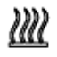
- Press the " " key and the "－" key at the same time for 3 seconds to open the child lock mode, do so again to close.
- SET means the target temperature. This is heating symbol.
- If the SET temperature is lower than the ROOM temperature, the heating symbol is not displayed.
- If the SET temperature is higher than the ROOM temperature, the heating symbol is displayed.
- When the room is heated to the SET temperature, then the remote control will stop displaying the heating symbol.
- Every time you press the button, the screen background will light up,and it will be off if no operation within 5 seconds.
Ⅵ. Instructions of WIFI Connection
- Before pairing, please make sure your mobile phone connects to your 2.4ghz WIFI signal invariably.
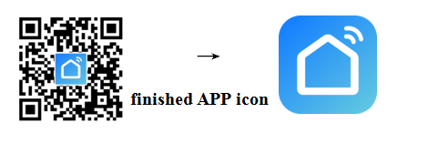
- Scan and install below Smart Life APP, and Register an account.

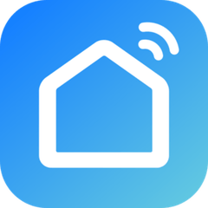
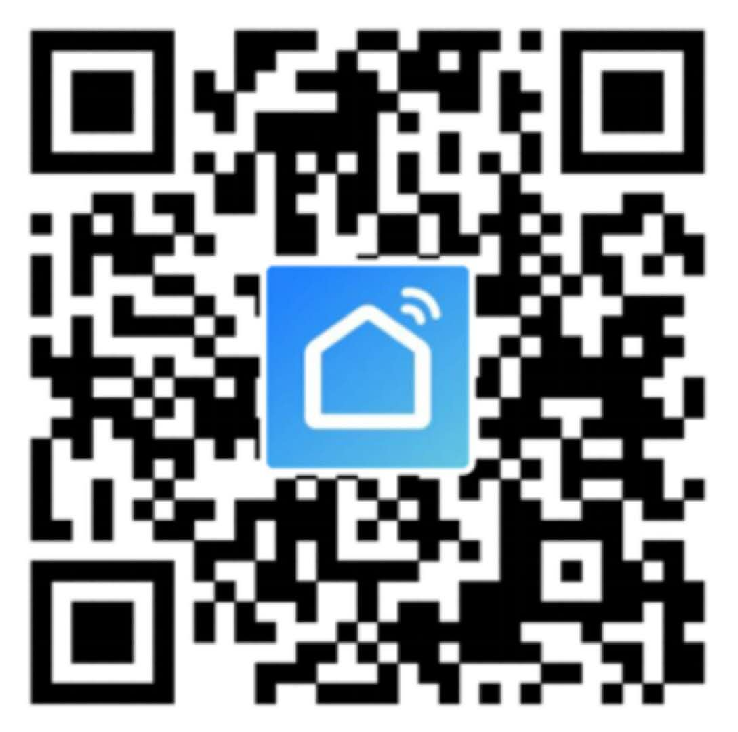
- Power on the heater and it will beep automatically. Long press the " " and "+" button of the remote control to pair it with the heater.
Long press the button of the remote control for 6 seconds until the blue indicator of the heater flashes, now the heater is ready for Wi-Fi setting.
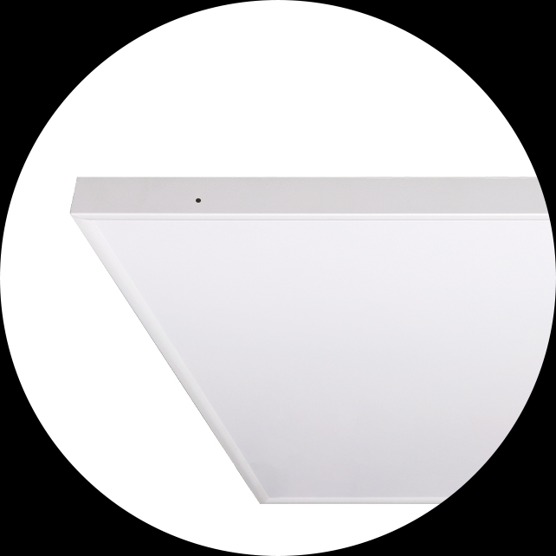
NOTE: same operation is necessary when WiFi hotspot changed, WiFi password changed, or cell phone changed..
Indicator light with red and blue colors

Blue color means online
Red color means heater powering on

- Click Smart Life App to enter main interface, Select room name and click “Add Device” or the upper right corner “ ” icon. A pop-up window appears as below picture.
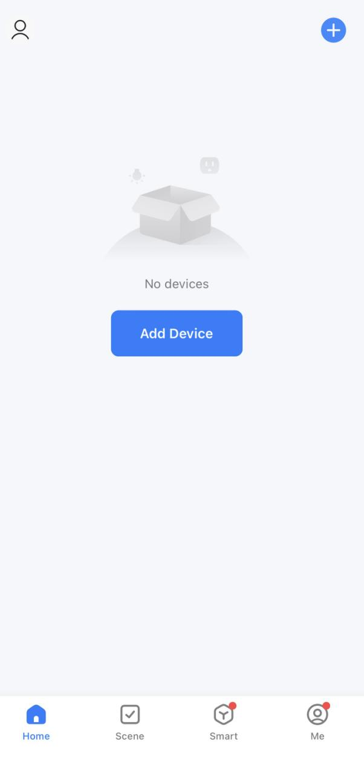

- Click “Add”, an Enter Wi-Fi Information dialog will pop-up as following.
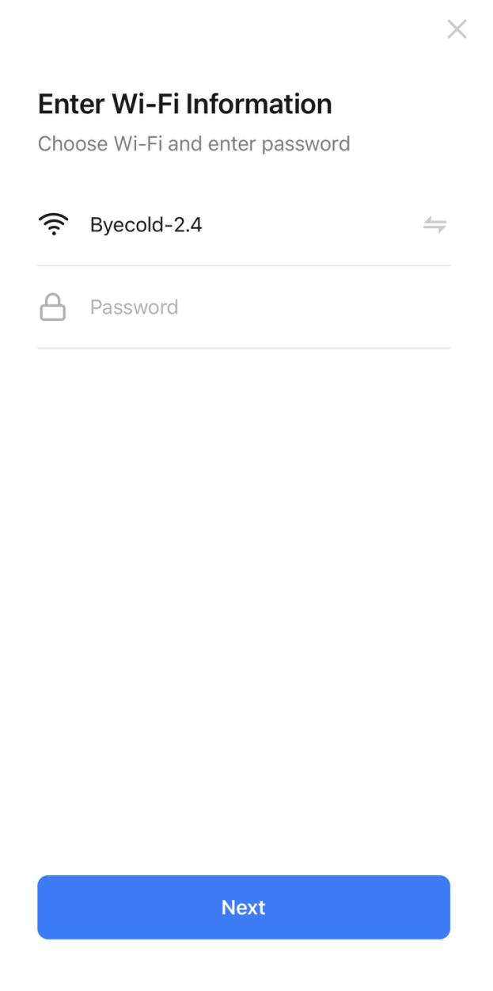
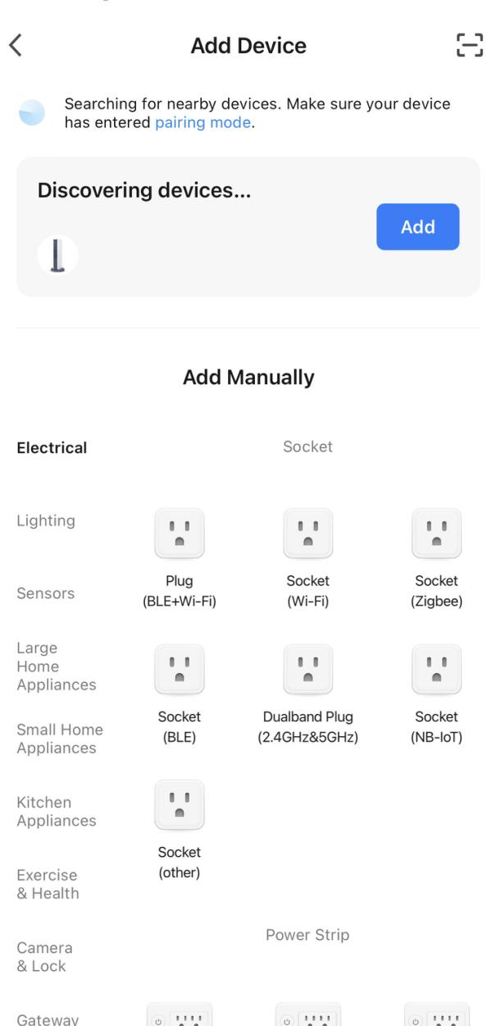

- Enter Wi-Fi password, click“Confirm”，It will automatically enter the next step for WIFI connection. The device will be added successfully after waiting for 20-30 seconds. And meantime the blue indicator at the front corner of heater lights up. You can name this device, e.g. “Infrared panel heater”.
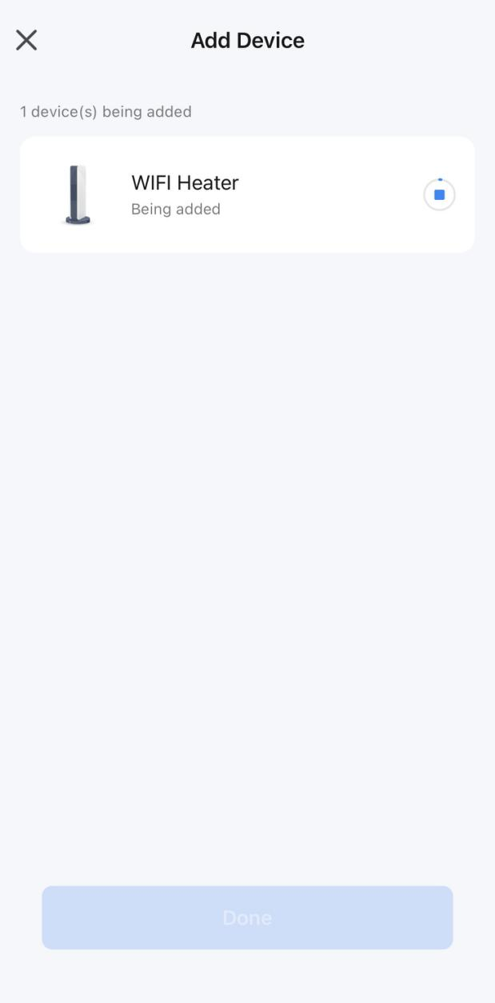
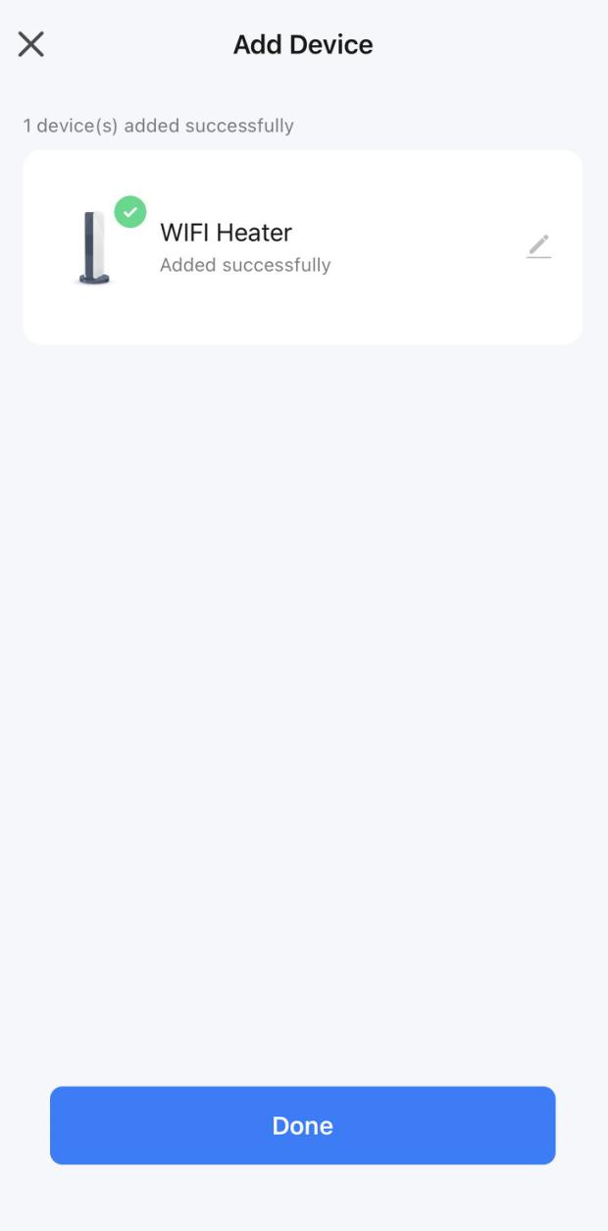

Note: If the connection is timed out in Step 6, please Repeat Step 3-6.
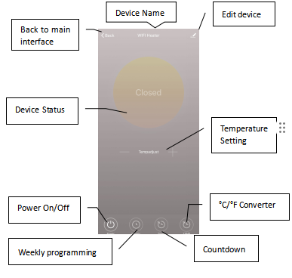

Ⅶ. Operation Instructions
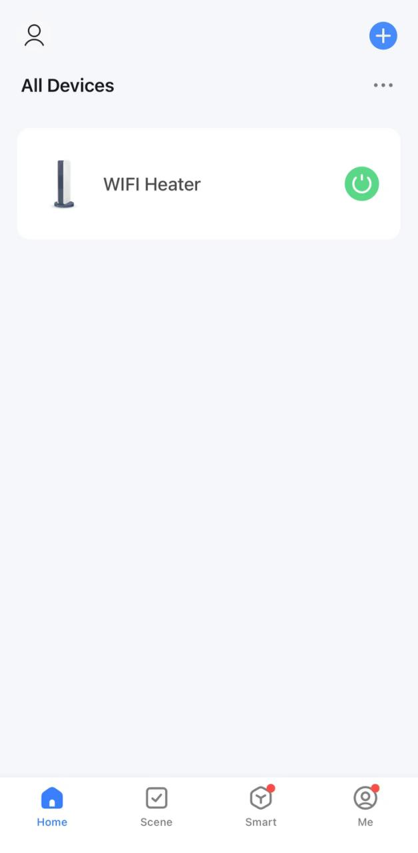
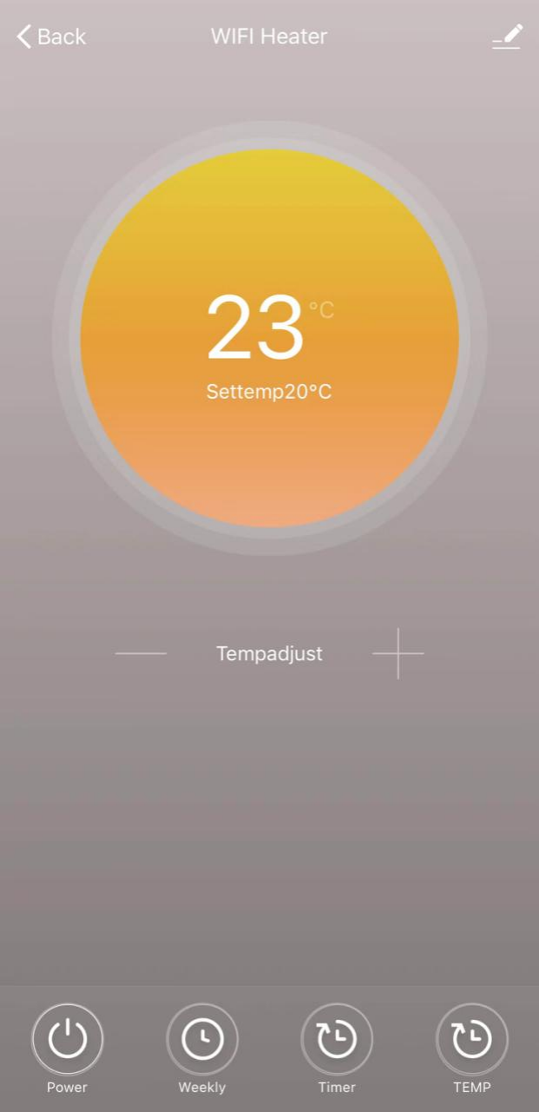
- Main view of the Smart Life APP after heater connected successfully as below.

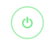
- Click the green to turn on/off the power supply of the heater, red indicator on heater panel lighting up means the heater has been powered on.
- Click device name “infrared panel heater” to enter the interface of the device.
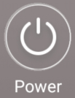
- means turning on/off the power supply of the heater, setting
temperature should be also at least 0.5 ℃ higher than room
temperature if you want the heater to be powered on.
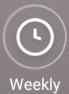
- means weekly programming mode. Under weekly mode, users can
program the heater to change the operation and desired temperature throughout the week. ON and OFF timing is separate, you need to add individually. Don’t forget to turn ON the weekly button to Green after programming..
Note: weekly will still work as per setting even under APP powering off state.
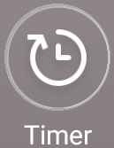
- is countdown function for setting to power off the heater.
Note: APP powering off will cause timer setting canceled.
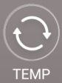
- means convert temperature display between ℉ and ℃
Note:Weekly, Timer and TEMP these three functions can be edited only under power on mode!

- means other editing of the heater, description as below.
- Device name: edit the thermostat name.
- Device information: to check the virtual ID etc device information.
- Share device: you can share the control of this thermostat to other mobile numbers/email addresses if they have been registered in “Smart Life” APP.
- Create Group: you can group different thermostats to control together.
- FAQ & Feedback: to report any problems to the APP supplier.
- Add to the home interface: you can turn on the heater directly on the home interface.
- Check Device network: check the wifi connection status of device.
- Check Update: Get latest firmware version.
- Remove Device: remove thermostat from your APP.
Ⅷ. Important note
- The heater only support 2.4GHz network.
- Blue light means the heater is online, red light means the heater is powering on.
- Thermostat disable switch on means disabling thermostat.
- WiFi or network disconnected will cause heater offline and heater powering off.
- The blue LED indicator may not light up at the first time when you finished the WIFI connecting, you need to wait for a couple of seconds due to network searching and connecting.
- Alkaline battery is recommended for the remote control. Please remove the battery if long time no use.
- If the remote can not turn on the heater, please check if the setting temperature is not high above the room temperature.
- Put the remote-controller at most 8 meters from the heater.
Do not mount the remote-controller close to any cold or heat source;
Do not cover the remote-controller;
Do put it in an open normal room environment rather not inside a drawer/pocket etc, or under pillow/quilt etc.
- Do not use heaters in wet or running water environment.
- Please pull out the heater power supply from your socket if long time no use.
- Both the remote-controller and App can turn on/off the heater and set the temperature. The remote-controller setting can be linked to the App, but the App setting cannot be linked to the remote-controller.
- If the connection between remote and the built in receiver breaks and the temperature data can't be received for 5 minutes, the APP will display --.-, and the heater will stop heating, meanwhile, the mobile will get a warning message. If the connection is done again, the APP will display real room temperature.
- If the remote-controller is disconnected, please bring the remote-controller close to the heater(less than 3 meters) and repair.
- If the remote-controller is always disconnected at one location, move it somewhere else.

