Installation & Operation Manual for
Electric Heater with Towel Warmer
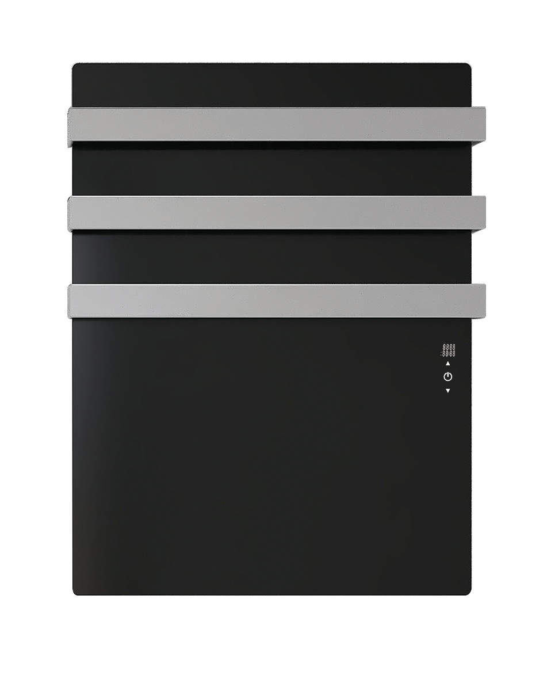

READ BEFORE USE
- Thank you for purchasing this towel warmer.
- Please read the instructions carefully before attempting to install, operate or service the product.
- Please keep this booklet for future reference.
- Pictures for reference only, subject to our available products.

SCOPE OF DELIVERY
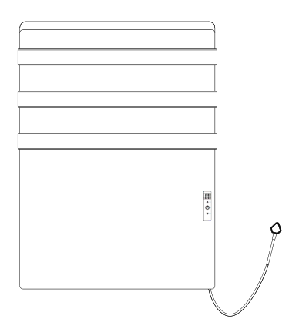
B
C
D
E
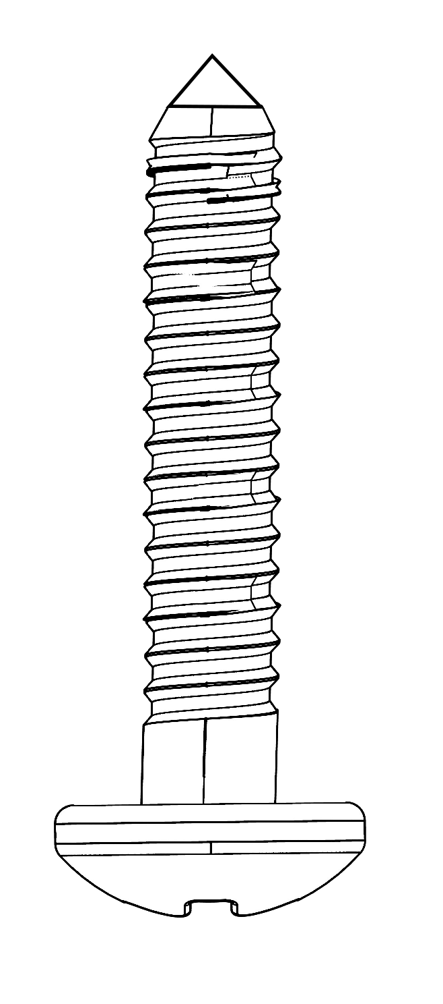
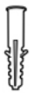
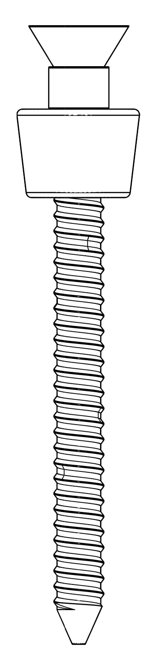
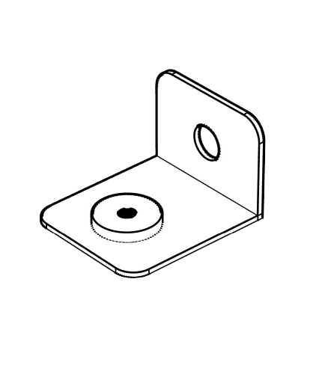

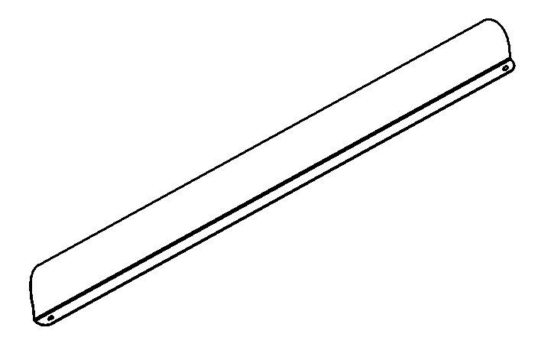
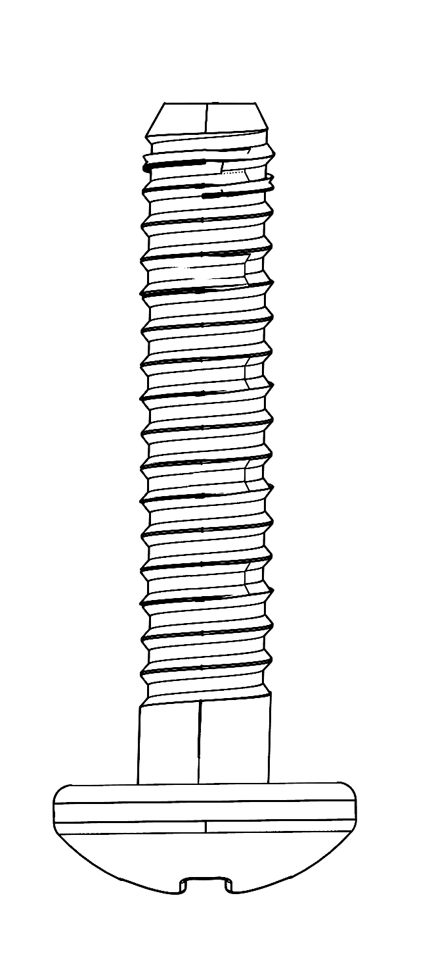
A
F
G
H


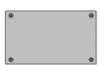

I
J

A: Electric Towel Rail ×1 | B: Screws ×2 (M4.8*50mm)
C: Expansion Plugs ×3 | D: Bottom Mounting Bracket ×1
E: Screw ×1 (M4.8*40mm) | F: Screw ×1 (M3*16)
G: Baffle ×1 Manual ×1 | H: Screw ×2 (M3.5*9.5mm)
I: Manual ×1 | J: Drilling template ×1

CONTENTS

1 | Safety Introduction
2 | Cleaning Information
3 | Installation
4 | Product Information
5 | Operation
6 | Important note
7 | Troubleshooting
8 | Warranty
9 | Disposal

- | SAFETY INTRODUCTION
Read this manual carefully before starting or using the device. Always store the manual in the immediate vicinity of the device or its site of use!

Read all safety warnings and all instructions.
Failure to follow the warnings and instructions may result in electric shock, fire and / or serious injury. Save all warnings and instructions for future reference.

Warning
The ambient temperature when using this device shall not exceed
30 degree.
Do not cover the surface of the device or block air vents.
Failure to follow these instructions may trigger the manual reset thermal cutoff, causing the device to stop heating!
Warning
Do not ceiling mount these devices designed for wall only!
Or else it may cause burning, fire and falling off risk!
Warning
This device can be used by children aged from 8 years and above and
persons with reduced physical, sensory or mental capabilities or lack of
experience and knowledge if they have been given supervision or instruction
concerning use of the device in a safe way and understand the hazards
involved.
Children shall not play with the device. Cleaning and user maintenance
Shall not be made by children without supervision.
Warning
Children of less than 3 years should be kept away unless continuously supervised.
Children aged from 3 years and less than 8 years shall only switch on/off the device provided that it has been placed or installed in its intended normal operating position and they have been given supervision or instruction concerning use of the device in a safe way and understand the hazards involved.
Children aged from 3 years and less than 8 years shall not plug in, regulate and clean the device or perform user maintenance.

Warning
Do not use the device in small rooms if persons are present who cannot leave the room independently and who are not under constant supervision.
Warning
This heater is hot when in use. To avoid burns, do not let bare skin touch hot surfaces. Keep combustible materials, such as furniture, pillows, bedding, papers, clothes, etc. and curtains at least 3 feet ( 0.9 m) from the front of the heater and keep them away from the sides and rear. the following people should be much more careful when using the heaters: infants and kids, people with sensitive skin, the old, the sick, people who is drunk, people who takes sleeping pills.
- Remove all the blue protective films(both on the front and on the back) before using.(If available)
- Install the device at least 600mm above the floor in order to avoid a hazard for very young children.
- Be sure the usage voltage is between 220-240V, 50-60Hz, and power supply has been strictly in accordance with IEC, left is null wire and right is live wire, and also well grounded.
- The devices will draw more current than small appliances, so a separate 10A socket is required.
- Do not use the device in potentially explosive rooms.
- The devices has hot and arcing or sparking parts inside. Do not use it in areas where gasoline, paint, or flammable vapors or liquids are used or stored.
- Do not use the device in aggressive atmosphere.
- Set the device up in an upright and stable position.
- Let the device dry out after a wet clean. Do not operate it when wet.
- Do not use the device with wet or damp hands.
- Do not expose the device to directly squirting water.
- Never insert any objects or limbs into the device.
- Never stand, sit on, or hang on the device unit.
- Do not cover or transport the device during operation.
- This device is not a toy! Keep away from children and animals. Do not leave the device unattended during operation.
- Check accessories and connection parts for possible damage prior to every use of the device. Do not use any defective devices or device parts.
- Ensure that all electric cables outside of the device are protected from damage (e.g. caused by animals). Never use the device if electric cables or the power connection are damaged!
- The electrical connection must correspond to locally relevant Electricity and Wiring Regulations.
- In order to avoid a hazard due to inadvertent resetting of the thermal cut-out this appliance must not be supplied through an external switching device, such as a timer, or connected to a circuit that is regularly switched on and off by the utility.
- Never drill into the heating device.
- Insert the mains plug into a properly secured mains socket.
- Do not use the device when the socket or wire overloaded.
- Observe the device's power input, cable length and intended use when selecting extensions to the power cable. Completely unroll extension cables. Avoid electrical overload.
- Before carrying out maintenance, care or repair work on the device, remove the mains plug from the mains socket. Hold onto the mains plug while doing so.
- Switch the device off and disconnect the power cable from the main socket when the device is not in use.
- Do not use the device under any circumstances if any damages on the mains plug or power cable. If the supply cord is damaged, it must be replaced by the manufacturer, its service agent or similarly qualified persons in order to avoid a hazard. Defective power cables pose a serious health risk.
- Do not use the device once any damage found on the glass surface.
- Do not use the device in immediate proximity to curtains.
- Do not place the device on combustible ground.
- Do not touch the surface during the device working to avoid burns.
- Allow the device to cool down before transport and / or maintenance work.
- Do not use this device near bathtubs, shower trays, swimming pools or other water containers. Risk of electric shock!
- The device must be placed where the switches and controllers cannot be touched by a person in a bathtub or shower.
- Do not use this device in a child-care centre and bathroom. (Only for Sweden)
- | CLEANING INFORMATION
- Ensure that the power supply to the towel rail is disconnected before any installation or maintenance.
- Clean the towel warmer with a soft, non-abrasive, damp cloth while warm.
- Once the towel warmer has cooled, lightly polish with a soft, dry cloth.
- Do not use abrasive cleaning powders, metal polish, or chlorine based cleaners on any part of the towel warmer.

- | INSTALLATION
This appliance must be installed in accordance with the instructions in the manual and the IEC guidelines relating to electrical fixtures in bathrooms. The towel warmer must be on a GFCI-protected circuit and be wired by a professional who is certified to do electrical wiring.
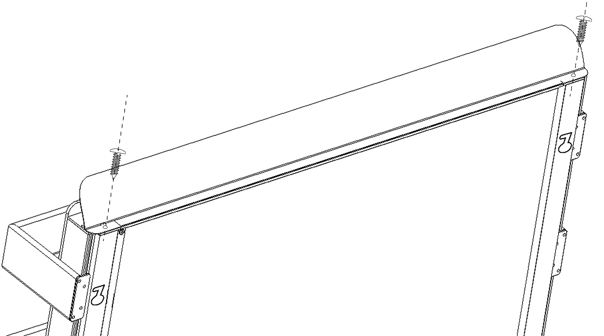
- Screw the screw "H" through the baffle "G" into the reserved hole on the top of the device as show in the diagram below.
H

H
G

- Choose the mounting position, keep the required minimum distances.
- Mark the positions for your mounting holes onto the template if there are no
existing marks. Stick the drilling template on the wall and drill the holes with an 8mm rotary bit.
Note: Excessive drilling diameter is strictly prohibited !

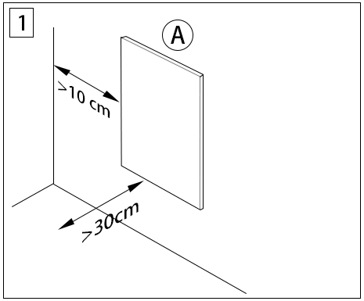
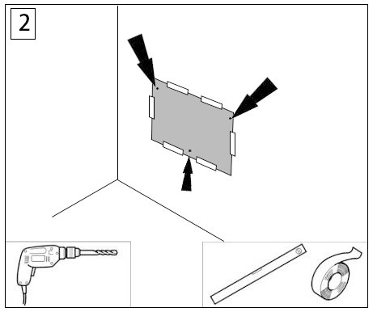

- Insert the expansion plugs into the drilled hole and screw the screw “B” into the top two holes first (screw B is equipped with a limiting device and screwing into the limited position is fine).
- Use screw “E” through the hole in accessory “D” and screw into the expansion plug at the bottom. Adjust “D” to the horizontal direction according to below.
2
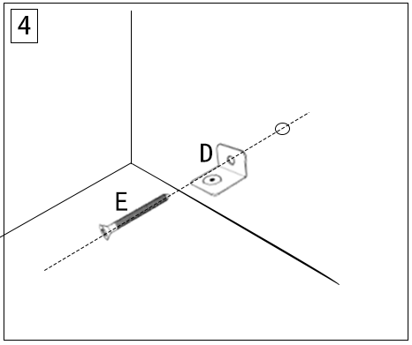
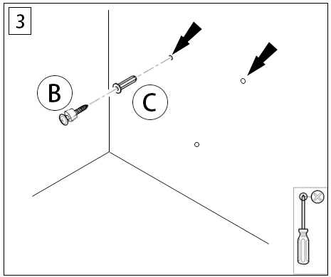

- Find the mounting holes on the back of the towel rail hang on the top two screws.
- Slid the device to get the screws into the correct positions as show in below picture.
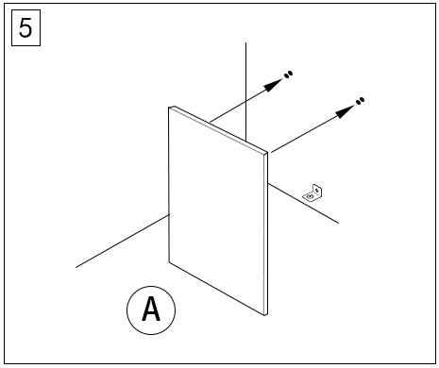
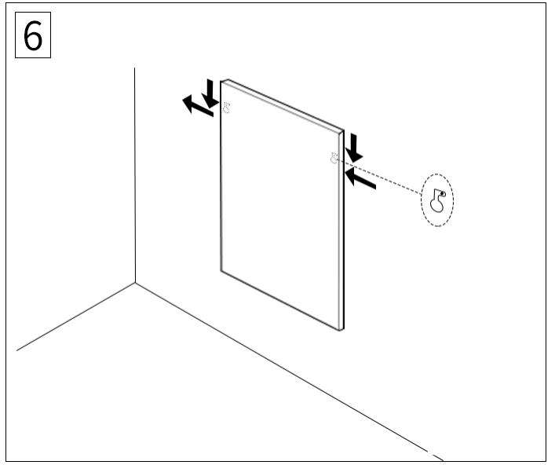

- USE screw “F” from the bottom of the towel rail upwards and into the threaded hole on the bottom bracket “D”.
- Plug in/wire in the heater and start using your device!
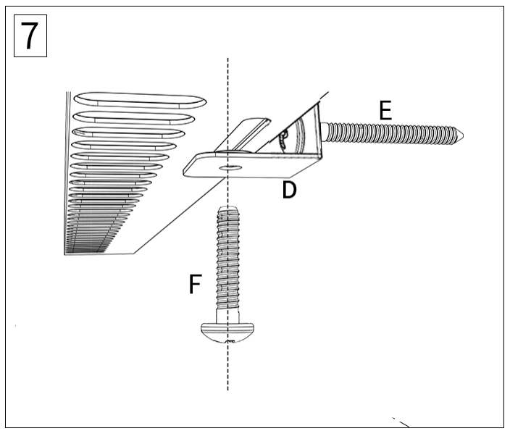
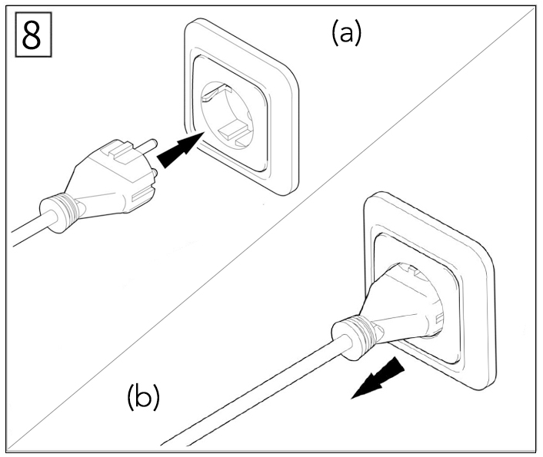

- | PRODUCT INFORMATION
TECHNICAL DATA
Material | Aluminum or Glass
Heating element | Graphene Carbon
Input Voltage | 230V/50Hz
Switch | Electronic
IP grade | IPX4
Over heating protection | Manual-reset thermal cutoff

Size(mm) | Heating Power(W) | Drying Power(W)
650*612 | 500 | N/A
650*612 | 500 | 30
850*612 | 700 | N/A
850*612 | 700 | 30
950*600 | 800 | N/A
950*612 | 800 | 30
1050*612 | 900 | N/A
1050*612 | 900 | 30
1250*612 | 1200 | N/A
1250*612 | 1200 | 30
- | OPERATION

Description
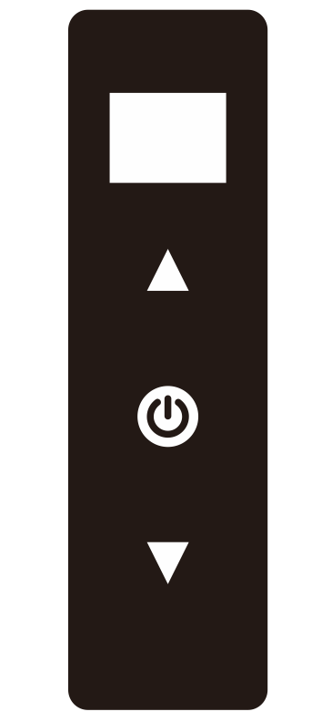
LCD Screen

UP

ON/OFF

DOWN

- The screen displays the room temperature and the target temperature, date &
time.
- Touch screen displays with mode selection, temperature adjustment and time setting;
- The product has two working modes: heating mode , a drying timer mode;
- The temperature sensor in the bottom of the towel rail reads the room
temperature and signals when to turn the towel rail on/off as the ambient temperature rises. When the room temperature is 0.5°C lower than the set temperature, the heater comes on. When the room temperature is 0.5°C higher than the set temperature, the heater turns off.

START-UP

1. Check if the power cord is intact.
2. Check if the power supply voltage is consistent.(The power socket is required to
have a grounding terminal and good grounding performance.)
3. Whether the power cord plug and socket are matched, the socket can withstand
minimum circuit requirement. If not, it cannot be used to avoid accidents.

Operation Instructions of Heating Function
Manually turn the panel ON/OFF
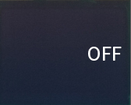
- When there this power to the towel rail socket “OFF” will appear on the screen.(Figure 1)

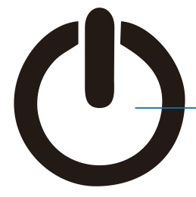
- In the standby mode, short press the button to turn the towel rail on and it will enter the heating mode. Short press the power button again to turn the heater off.
Set the Time and Day
It is essential that the time and day are set accurately if you require your programmed time slots to start on time.
Step 1. Press and hold button ▼for more than 1.5 seconds to until the hour begins flash, use ▲ or ▼ button to adjust the hour. Press and hold button ▼again for more than 1.5 seconds enter next setting and proceed with setting the minutes and day.
Step 2. After setting this, if you wait 8 seconds,the heater will automatically save and exit.
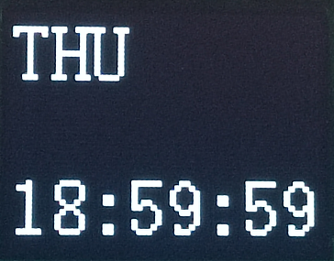
Note: In each working mode, the display will scroll every 3 seconds to display the current time.

How to switch working mode?
Press and hold button for more than 1.5 seconds to switch the working mode.
°C/°F Display
Press and hold button ▲ and ▼ for more than 1.5 seconds simultaneously to convert Celsius/Fahrenheit or Fahrenheit/Celsius.
Heating mode
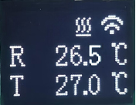
Heating
symbol
WIFI symbol
Room temperature

Set
temperature

Ⅰ. Instructions of WIFI Connection
- Before pairing, please make sure your mobile phone connects to your 2.4ghz WIFI signal invariably.
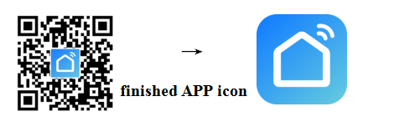
- Scan and install below Smart Life APP, and Register an account.

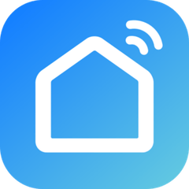


- Long press the button “ “ and " ▲" at the same time for 3 seconds until the WIFI symbol flashes, now the heater is ready for Wi-Fi setting.
NOTE: same operation is necessary when WiFi hotspot changed, WiFi password changed, or cell phone changed.
This symbol means online
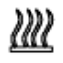
This symbol means heater is heating up

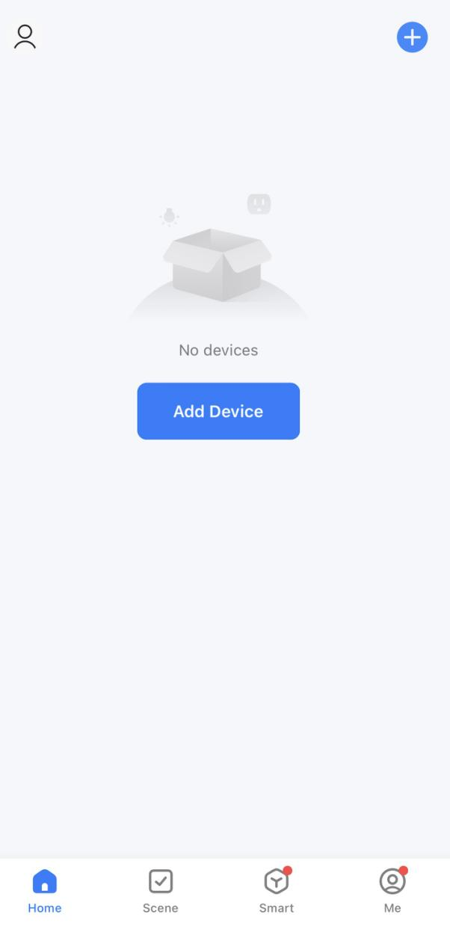
- Click Smart Life App to enter main interface, Select room name and click “Add Device” or the upper right corner “ ” icon. A pop-up window appears as below picture.

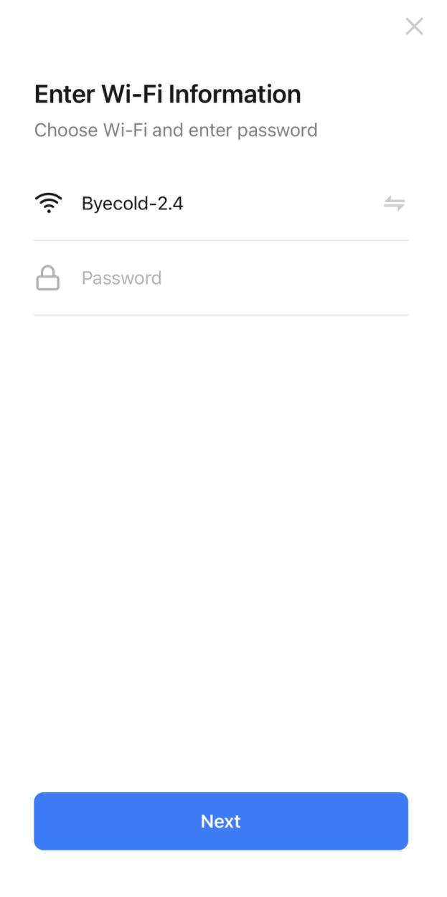
- Click “Add”, an Enter Wi-Fi Information dialog will pop-up as following.
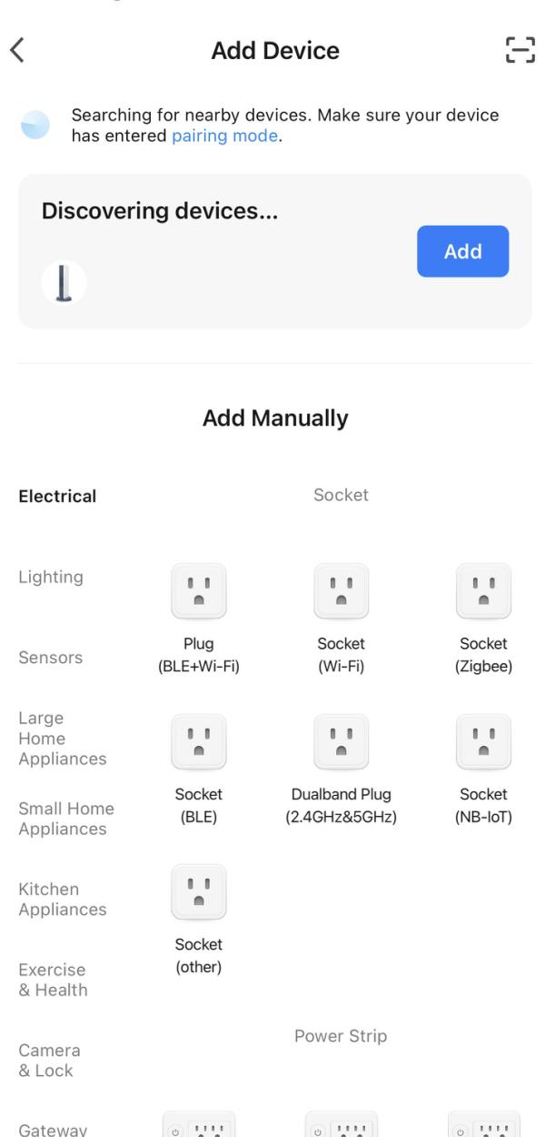

- Enter Wi-Fi password, click“Confirm”，It will automatically enter the next step for WIFI connection. The device will be added successfully after waiting for 20-30 seconds. And meantime the WIFI symbol lights up. You can name this device, e.g. “WIFI Thermostat heater”.

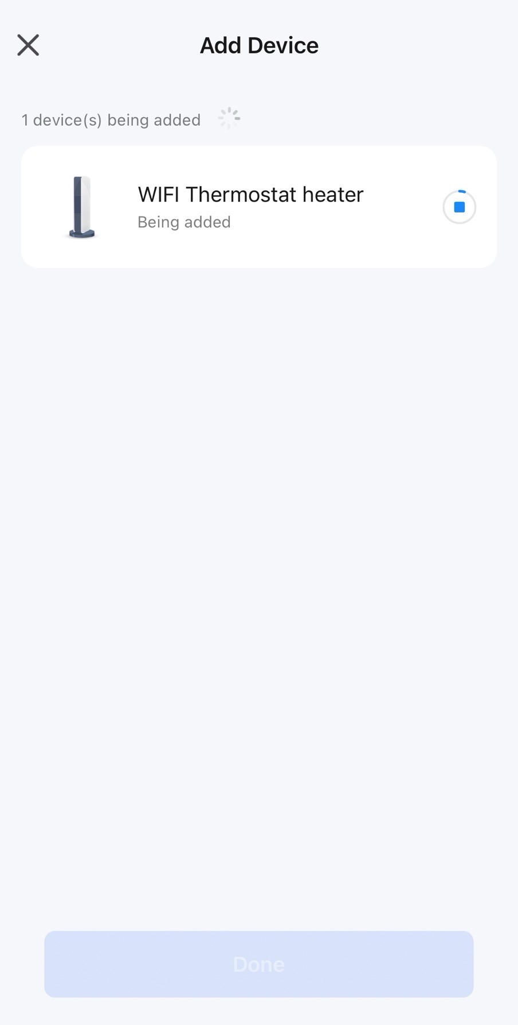
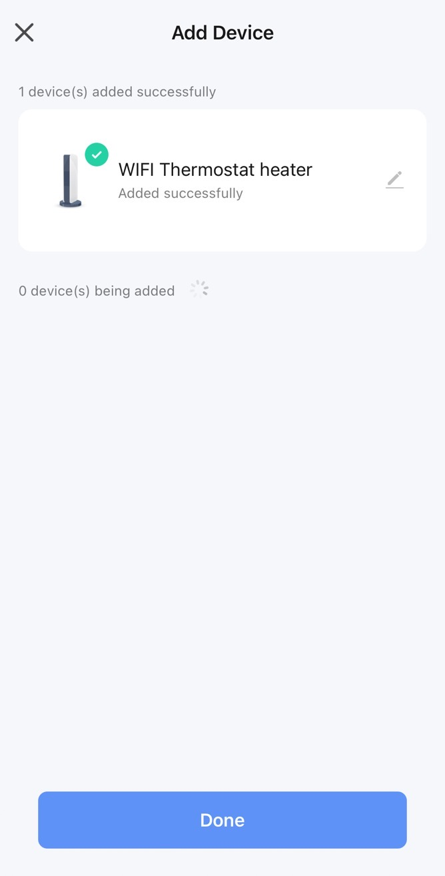

Note: If the connection is timed out in Step 6, please Repeat Step 3-6.

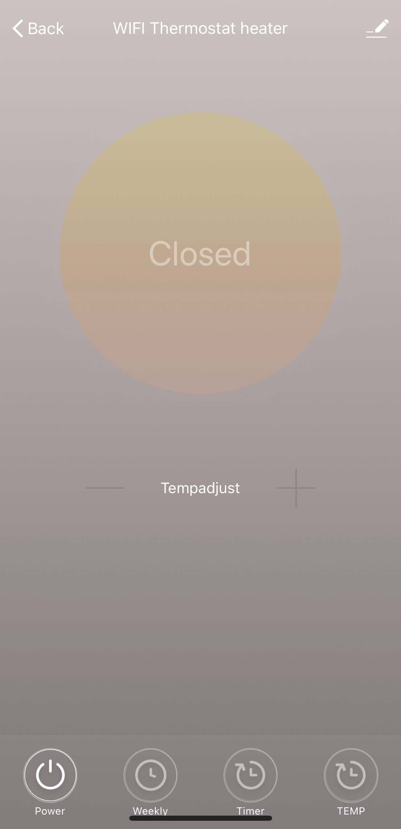
Edit device
Back to main interface
Device Name
Device Status
Power On/Off
Temperature Setting

Weekly programming
Countdown
°C/°F Converter

Ⅱ. Operation Instructions
- Main view of the Smart Life APP after heater connected successfully as below.
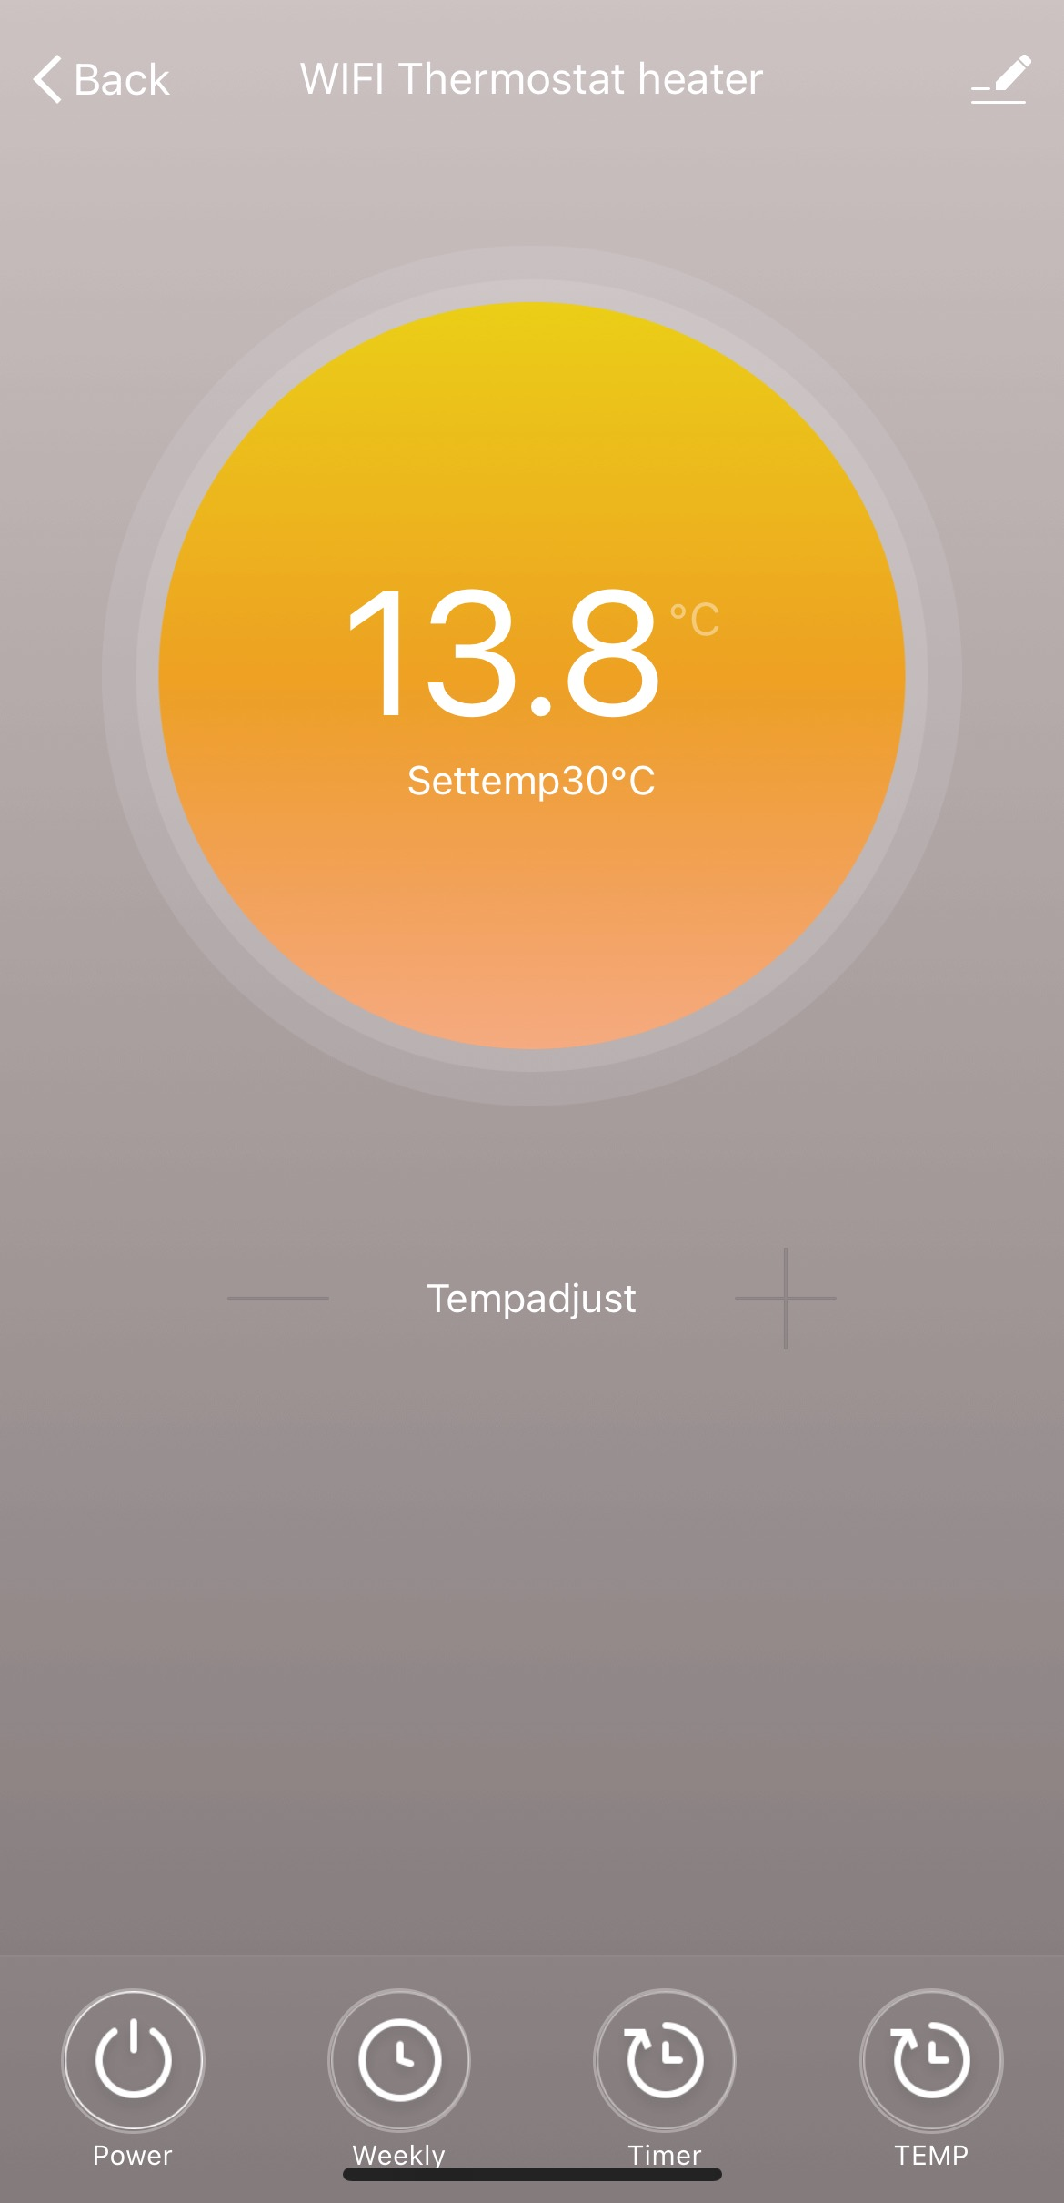
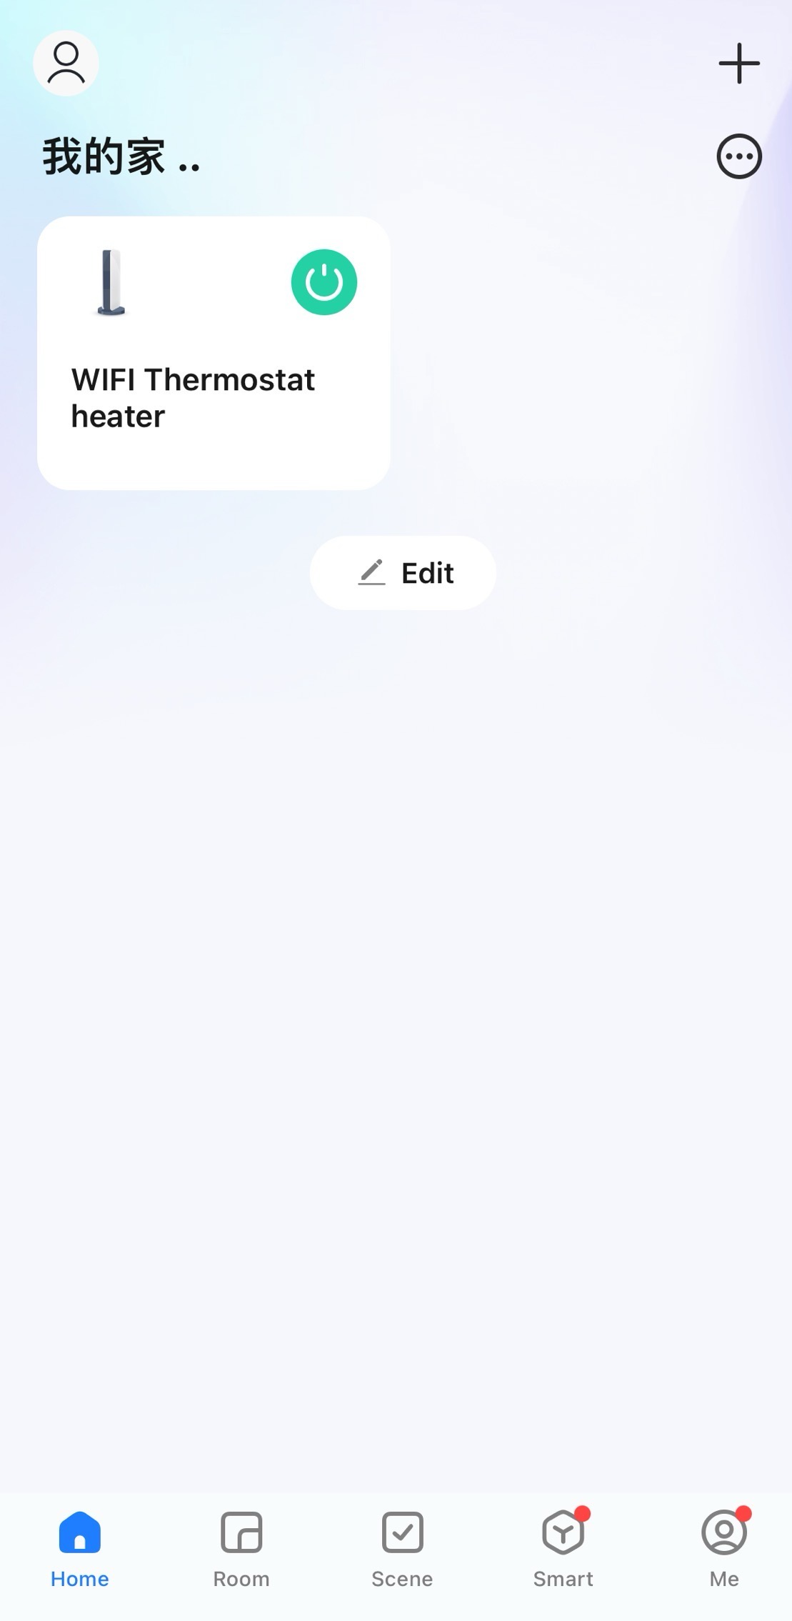


- Click the green to turn on/off the power supply of the heater.
- Click device name “WIFI Thermostat heater” to enter the interface of the device.
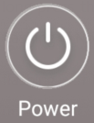
- means turning on/off the power supply of the heater, setting
temperature should be also at least 0.5 ℃ higher than room
temperature if you want the heater to be powered on.

- means weekly programming mode. Under weekly mode, users can
program the heater to change the operation and desired temperature throughout the week. ON and OFF timing is separate, you need to add individually. Don’t forget to turn ON the weekly button to Green after programming..
Note: weekly will still work as per setting even under APP powering off state.
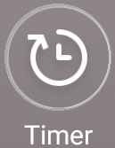
- is countdown function for setting to power off the heater.
Note: APP powering off will cause timer setting canceled.
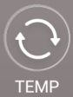
- means convert temperature display between ℉ and ℃
Note:Weekly, Timer and TEMP these three functions can be edited only under power on mode!

- means other editing of the heater, description as below.
- Device name: edit the thermostat name.
- Device information: to check the virtual ID etc device information.
- Share device: you can share the control of this thermostat to other mobile numbers/email addresses if they have been registered in “Smart Life” APP.
- Create Group: you can group different thermostats to control together.
- FAQ & Feedback: to report any problems to the APP supplier.
- Add to the home interface: you can turn on the heater directly on the home interface.
- Check Device network: check the wifi connection status of device.
- Check Update: Get latest firmware version.
- Remove Device: remove thermostat from your APP.
Ⅶ. Important note
- The heater only support 2.4GHz network.
- WiFi or network disconnected will cause heater offline and heater powering off.
- Do not use heaters in wet or running water environment.
- Please pull out the heater power supply from your socket if long time no use.

Drying timer mode (Optional)
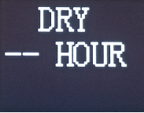
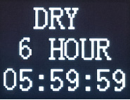
Set duration
Remaining duration

Press and hold the button for more 1.5 seconds to switch to the drying timer mode, the second line ‘—’ will begin to blink, short press ▲ to adjust the time (It can only be adjusted to a maximum of 6 hours) and short press ▼ to decrease the timer. After setting the timer please wait 8 seconds and the towel rail will automatically save if no other buttons are pressed.
Tips:
- When switching to the drying countdown mode, the drying is usually on by default, and "--" is displayed by default for the set period, and the remaining period is not displayed.
12
- Countdown ends or short press button to power off, and press button again to power on. If the countdown time has been set, reset the timer when the machine starts up again; If the countdown time is not set, it will enter the dry normally on state when starting again.
- In the countdown state, reset the setting time to "--" to resume the normal drying mode.
- | Important note
- Keep towels away from heater surface.
- During installation and use, please pay attention to the temperature probe at the lower right corner of the product to avoid damage, if this is damaged it can affect the temperature readings.
- Do not cover the temperature probe.
- Please disconnect the heater if it not going to be used for a long time.
- | Troubleshooting
Problem | Reason | Measure
The heater stops heating, but the  indicator light continues to operate normally. | The manual reset thermal cutoff was triggered (automatically shuts off power when the internal temperature exceeds the cutoff temperature).  It may have been triggered due to one of the following reasons:  a) Overheating - Poor ventilation, blocked air vents, or covered heater.  b) High ambient temperature - Used to an environment exceeding 30℃.  c) Power supply issue - Voltage fluctuation may cause abnormal operation. | 1) Unplug the power cord immediately.  2) Wait at least 10 minutes for the heater to cool down.  3) Check and resolve the root cause:  - Ensure power supply is stable;  - Check and remove any obstructions blocking airflow;  - Do not set the thermostat above 30℃ to prevent overheating;  4) Plug in again - The heater should resume normal operation.  Note: If the heater does not  restart, ensure it has cooled for at least 10 minutes before reconnecting power.
The surface of the heating device is slightly warm. | 1. The voltage is low.  2. In a low-temperature environment. | 1. Install a voltage regulator.  2. It is normal.
- | WARRANTY
THANK YOU FOR CHOOSING TO BUY THIS PRODUCT.
Customers can contact us for repairing or replacement of your appliance if it is found to be defective due to faulty materials, workmanship or function within the warranty period.
We do not guarantee the repair or replacement of a product where a defect is the result of:
- Damage caused by not carrying out the recommended appliance maintenance.
- Accidental damage, faults caused by negligent use or care, misuse, neglect, careless operation or handling of the appliance which is not in accordance with our Operating Manual.
- Use of the appliance for anything other than normal domestic household purposes.
- Faulty installation.
- Repairs or alterations carried out by parties other than authorised agents.
If you are in any doubt as to what is covered by your guarantee, please do feel free to contact us.

- | DISPOSAL
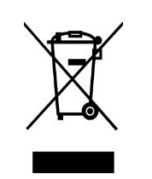
The icon with the crossed-out waste bin on waste electrical or electronic equipment stipulates that this equipment must not be disposed of with the household waste at the end of its life. You will find collection points for free return of waste electrical and electronic equipment in your vicinity. The addresses can be obtained from your municipality or local administration.

The separate collection of waste electrical and electronic equipment aims to enable the re-use, recycling and other forms of recovery of waste equipment as well as to prevent negative effects for the environment and human health caused by the disposal of hazardous substances potentially contained in the equipment.

Warranty Card

NAME TEL
ADD
MODEL ORDER NO.
Date
Failure Description

