PANEL HEATER

INSTRUCTION MANUAL

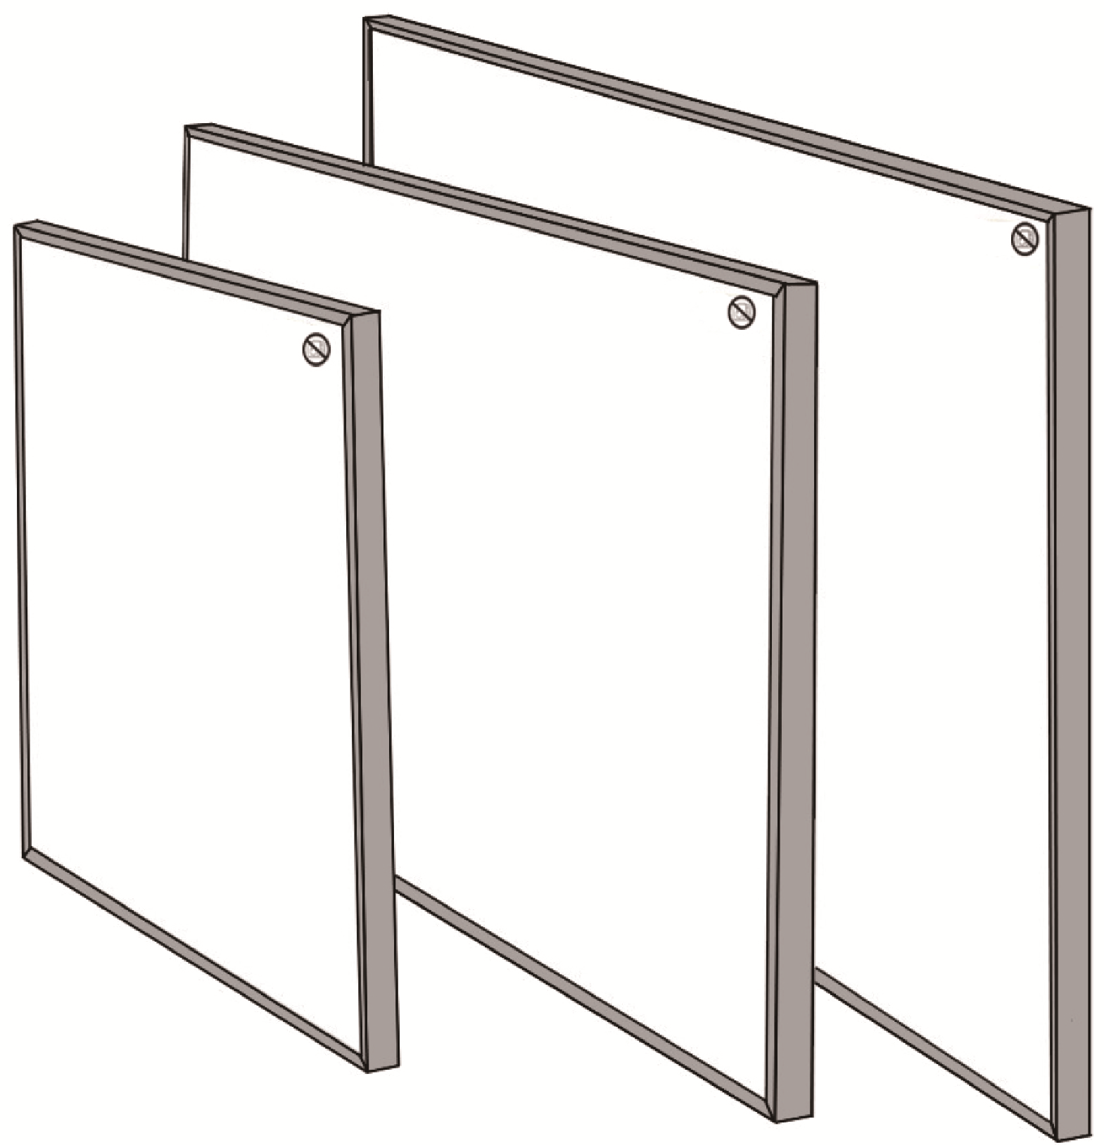

SYMBOLS
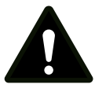Warning
This signal word indicates a hazard with an average
risk level which, if not avoided, can result in serious
injury or death.
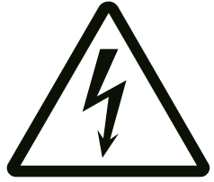Warning of electrical voltage
This symbol indicates dangers to the life and health of
persons due to electrical voltage.

Symbols | Meaning
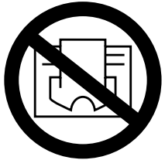 | This symbol located on the device indicates that it is  prohibited to place objects (such as towels, clothes etc.)  above or directly in front of the device.  In order to avoid overheating and fire hazards, the device  must not be covered.
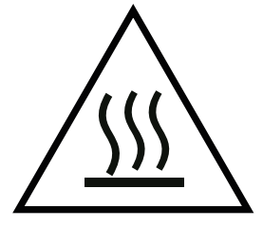 | This symbol located on the device indicates dangers to the  life and health of persons due to hot surface.
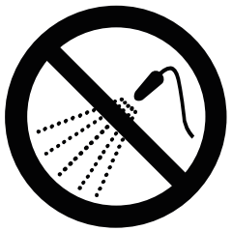 | This symbol located on the device indicates that it is  prohibited to spray the device.
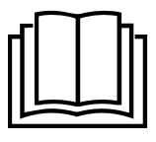 | This symbol located on the device and information marked indicates that operating manual must be observed.

Instruction for Ceiling Mounting Way C:
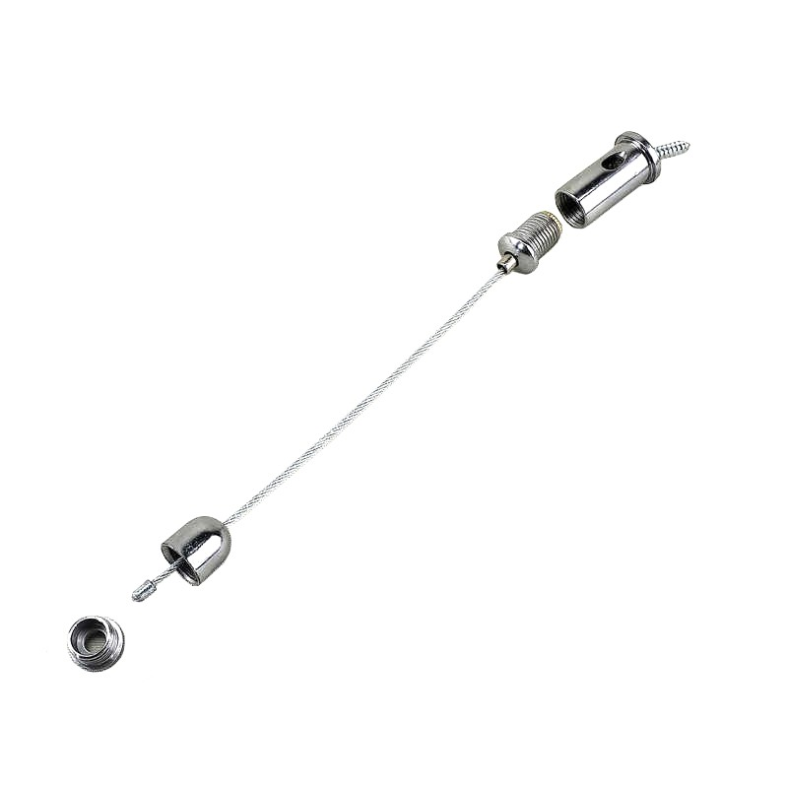
Only if below ceiling mounting wire sets included.
L
M
K
N
O

P

- Drill four 2mm diameter holes on the rear of the panel frames if there are no such small holes exists. Insert short screws(P) through 'L' and screw them into the frame holes with a screwdriver.
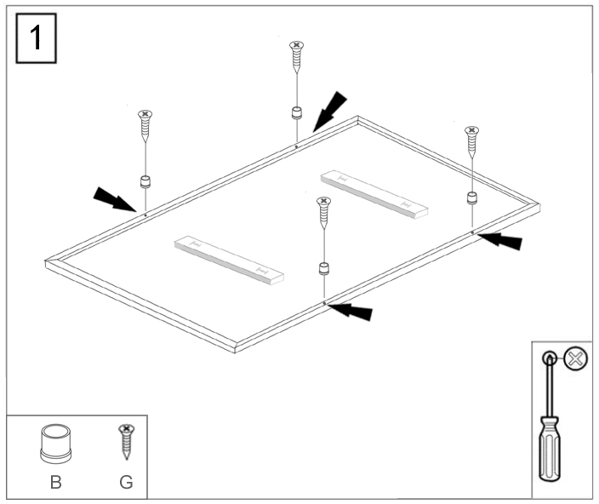
Note: Avoid using power tools as excessive torque can cause the screws to slip!

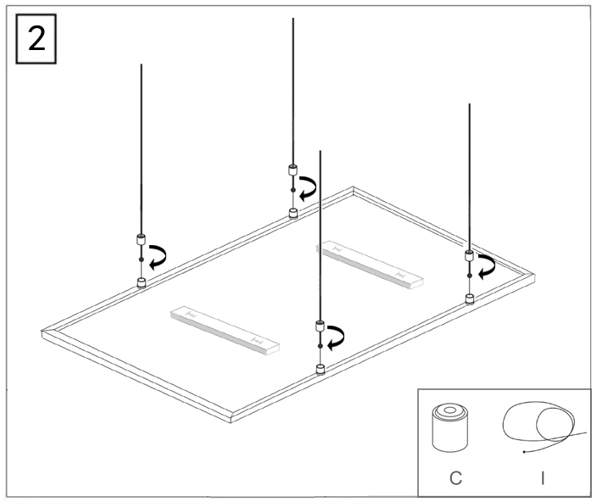
- Tighten wires(K) to 'L' by screwing 'M' .

- Concrete ceilings use metal expansion tubes, and gypsum board ceilings use spring toggles.
- Thread screws(G) through the metal components(O), then screw it into the metal expansion tubes(F) or the spring toggles (H), and tighten the screws.
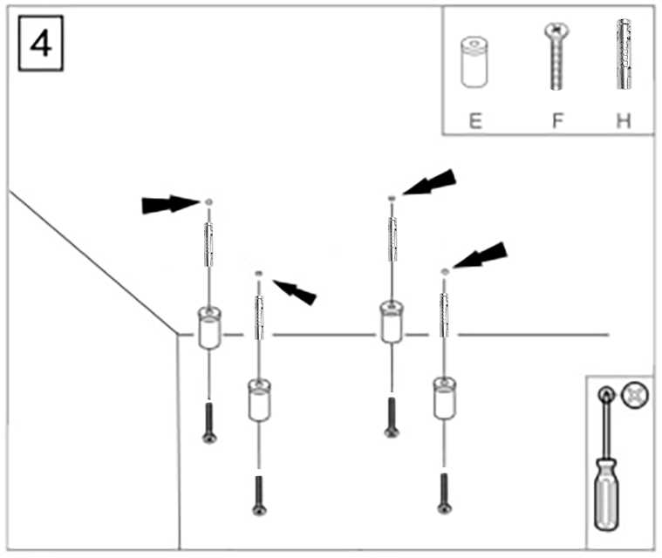
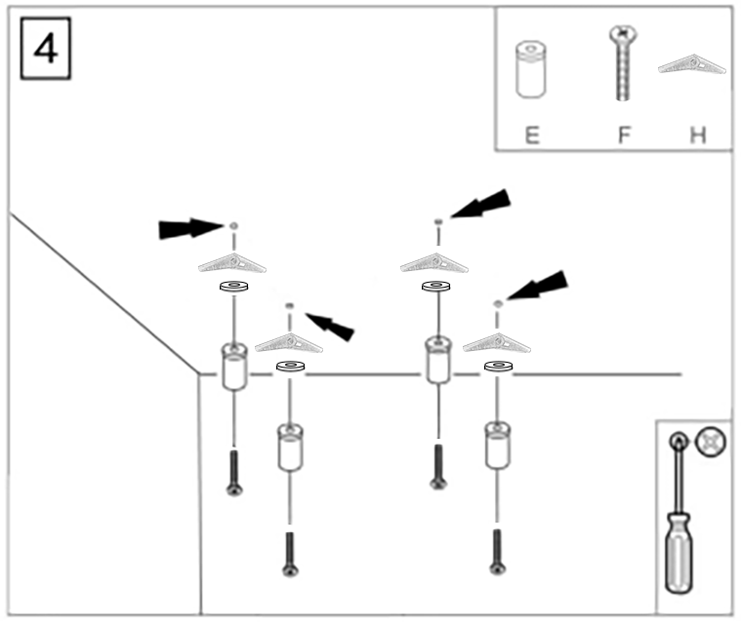

or

- Screw the top lock metal head(N) into the metal component (O) and tighten it.
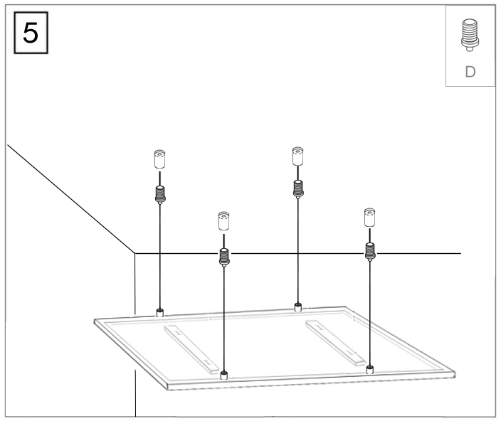

- Press the automatic locking extractor to adjust the desired length of the steel wire.

Release the locking extractor, then it will lock the wire automatically.

